

Database Management Systems

CSC375

Dr. Ramzi R. Haraty

**StarkSafe Police Station**

**A Beacon of Hope**

Sponsored by



ROKT.N Members

**R**azan Hourani - **202206922**

**O**mar Mayassi - **202202001**

**K**arim Hallal - **202202695**

**T**ala Kahil – **202205261**

**N**our Rida - **202203770**

**November 1st, 2023**

# Backstory

We cannot speak about StarkSafe without speaking about Stark himself. Tony Stark is a fictional character (in our hearts, he’s real) created by the Marvel Universe. He is more commonly known as Iron Man. Now Tony was not any ordinary man. Not just because of obvious superhero reasons, but because he is a genius, a billionaire, and a truly charming man. In his own words:

***“Genius, billionaire, playboy, philanthropist”***

StarkSafe’s sponsor, Stark Industries, is not your everyday investor. They are the heart and soul of Starkafe, and thus they are the heart and soul of our city. It also helps that they are a starring name in innovation, leading the market in technology wonders. One would assume Tony Stark is the founder of Stark Industries, but in fact he is his father’s heir. Tony did not only inherit the company from his father, he also inherited his brilliance and knack for turning dreams into reality.

Tony’s story is not all of success. His life took a dramatic turn once he was kidnapped and brutalized by terrorists demanding money. However, his intelligence got him out. Tony managed to build a smart suit of armor designed to fight enemies. This was the birth of Iron Man. To be honest, Stark’s journey with his suit is not the best, apparently, someone heard him whine  ***“How do you even go to the bathroom in the suit?”.*** As always though, there’s *nothing* impossible in Stark’s world. He created a built-in filtration system.

On a more serious note, his trauma put him on a mission to prevent crime. And after realizing how underfunded police stations are (i.e he was frustrated by how long his case took, afterall money and intelligence almost always come with ego), Stark set out to build a beacon of hope and innovation.

***“ I came to realize that I had more to offer this world than just making things that blow up.”***

Thus, the birth of StarkSafe Police Station (the ego strikes again, who names a police station after themselves?). StarkSafe is a state-of-the-art station that combines Stark’s love for technological innovation and peacekeeping. StarkSafe gave hope to the next generation of police officers and innovators. StarkSafe is a community that not only saves lives and maintains peace, but it is a true testament to the power of compassion and innovation.

# System Description

StarkSafe is situated in the heart of Beirut. However, its cutting-edge inspiring operations have led it to accept cases from all over the world. Established in 2050, StarkSafe is not only a beacon of hope to Beirut but to the entire world. With its groundbreaking technology, StarkSafe has been able to successfully investigate and solve crime cases remotely. Once you enter this sanctuary of law enforcement, you will not only be greeted by StarkSafe’s bravest and brightest human minds but also by striking humanoids, designed to tailor to every need possible. Hand in hand, man and machine have been able to give StarkSafe a strong name in both the worlds of law enforcement and innovation.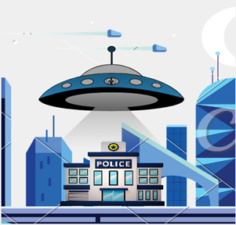

Upon stepping foot in one of the training rooms, you will witness humanoids guiding recruits through rigorous training programs that tailor them to be the best police officers they can possibly be. Our training programs are a great example of how traditional facilities now utilize a balanced mix of human and robotic personnel to guarantee optimal operation.

The core of StarkSafe is the dedicated and hardworking team. At StarkSafe, employees have several specialized roles consisting of anywhere between security officers, technology specialists, dispatch center responders, and customer support agents (Dani from dispatch would be really angry if you confused his role with customer support). Each role contributes significantly to StarkSafe’s mission.

StarkSafe’s extensive database and predictive algorithms can anticipate potential threats as it rigorously stores criminal information. StarkSafe’s database is designed to keep track of all previous criminal activity and the status of ongoing investigations. Its state-of-the-art database is a fortress of security making sure that all the sensitive information stored remains set in stone. Alas, it is time to make Stark proud (as if his pride and ego were not enough).

1. Entity Relationship Diagram

# Entity Types

## EMPLOYEE

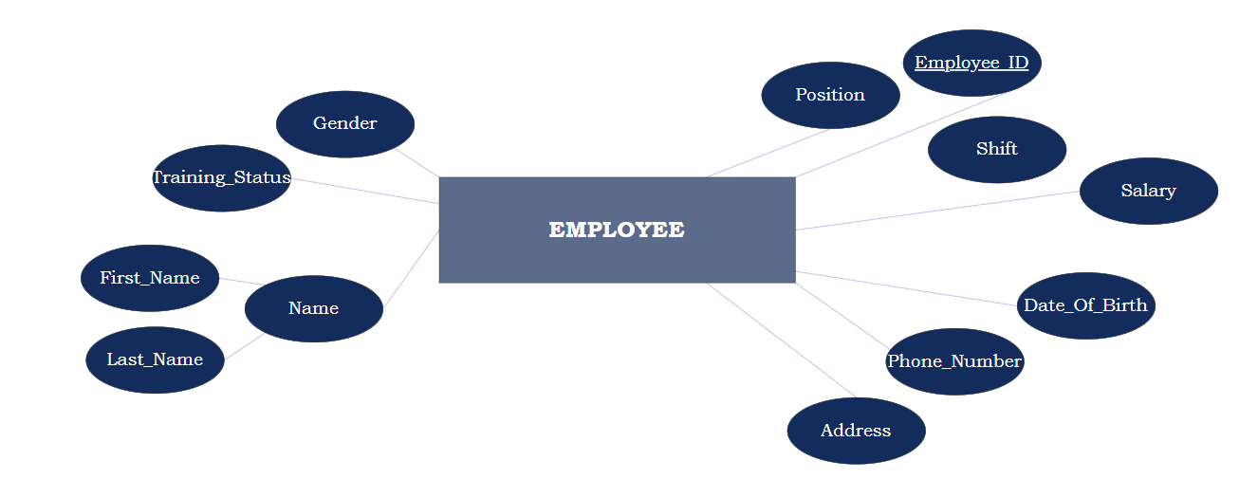

Not all heroes wear capes, some of them wear badges. The EMPLOYEE entity type consists of a different cast of characters, each with a different role at StarkSafe. This entity type can be uniquely identified by the EMPLOYEE_ID which is a key attribute. The **Name** attribute is a composite attribute composed of **First_name** and **Last_name**. This entity type also entails the **Address**, **Phone_Number**, and **Gender** of the EMPLOYEE. Furthermore, **Date_of_birth** indicates the birthdate of each EMPLOYEE. **Position** specifies the role of the EMPLOYEE at StarkSafe, from nerdy tech-geniuses to superhero crime-fighters, everyone at StarkSafe works together to ensure the safety of our city. To add, this entity type logs the **Shift,** which refers to the specific time period during which an employee is scheduled to work. **Training_status** logs information about whether our employees have completed their required training to become official full-time members of StarkSafe or not. Finally, **Salary** is the EMPLOYEE’s compensation for keeping the city safe. Not as much as Tony Stark, but just enough to cover those coffee runs in between shifts.

## ROBOT_EMPLOYEE

Working with Stark Industries gives us an extreme upper-hand when it comes to the world of high-tech. ROBOT_EMPLOYEE entity type can be uniquely identified by its key attribute EMPLOYEE_ID which is just like a social security number but without tax season dread. The **Position** specifies the job title of our mechanical friend. Furthermore, our robots are far beyond a piece of Vibranium metal, which is why they have names. The **Name** attribute indicates the names bestowed on our fellow robot (you know, so you can call him to fetch you a coffee). Besides, **Maintenance** logs some information about the robot’s maintenance. It is just like a spa day to get our robots back on track. **Storage_Location** specifies where our robots are stored when they are off-duty, attached to charging ports or sitting in dark quiet corners (or fetching coffee). Lastly, **Manufacturing_Date** indicates the date they freshly rolled out of the Stark Industries’ oven, sort of like their birthdate.

## UNIT

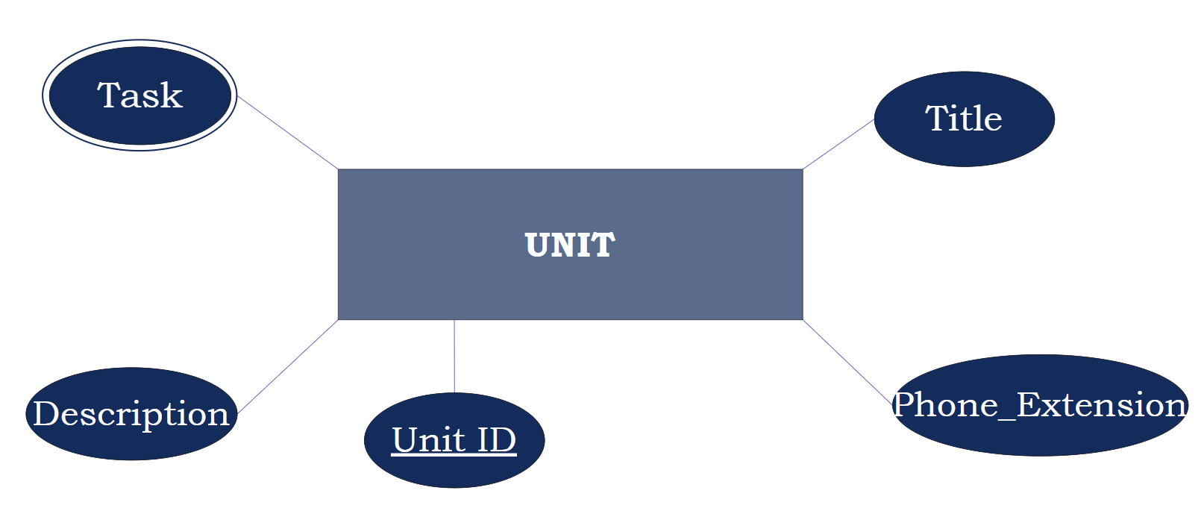

In the bustling world of StarkSafe, think of a UNIT as a squad of crime-fighting superheroes, each having their unique Unit_ID as their secret identity. This ID is a primary key used to uniquely identify the UNIT entity type. To add, the **Title** helps in making these units instantly recognizable both for officers navigating the station and citizens who might be wondering who's who in the crime-fighting world. Then there's the **Phone_extension**, ensuring officers can instantly reach relevant units, thus enhancing communication and response times during emergencies. Communication is key, after all. The **Description** attribute provides a brief overview of the unit's specific role and responsibilities telling you what they're all about. The multi-valued attribute **Task** plays a crucial role in task allocation, making sure that everyone knows which villain they need to chase down next, or which house to head to for partying too hard.

## TRAINING_PROGRAM

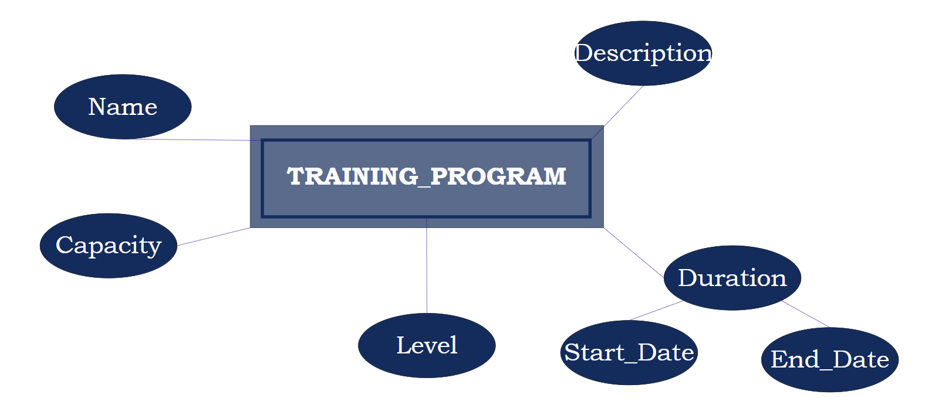

Our training programs are nothing short of extraordinary, for they turn regular folks into well-versed crime-fighting superheroes, otherwise known as police officers. TRAINING_PROGRAM is a weak entity type that is described by a **Name** which could be considered as a partial key. The **Description** serves as a sneak peek of what to expect in the program, giving our recruits a mild taste of the adventures awaiting them. The **Duration** attribute is composed of two other attributes: **Start_date** and **End_date**. It specifies how long our soldiers have to endure blood, sweat, and perhaps tears in order to become fully-fledged fighters. **Capacity** indicates the number of spots available for the program. And finally, **Level** is equivalent to choosing a difficulty setting, whether it be easy, intermediate, or hard. And hey, remember the coffee-fetching robots? They’re the instructors.

## POLICE_CAMERA

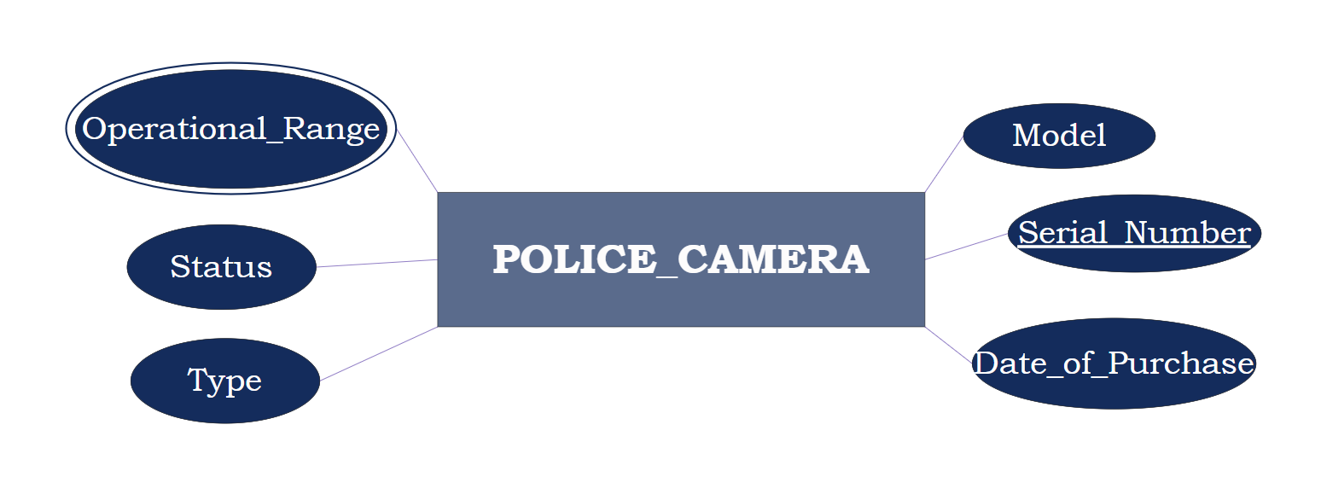

In this peaceful city, criminals are not safe from POLICE_CAMERAs. These gadgets continuously record all the mischievous actions taking place on the streets of Stark City, granting constant security to all our citizens. Every POLICE_CAMERA can be identified by its Serial Number which is considered a key attribute for this entity type. The **Type** attribute determines whether it represents a CCTV, a body-worn camera, or a dash camera. POLICE_CAMERAs also have other attributes such as **Date_Of_Purchase** which shows the specific time it became part of the crime-fighting family, **Status** which defines if the camera is in use or on a much needed break, and **Model** which represents the model of the camera as released by its manufacturer (Don’t tell Stark we deal with other manufacturers. His cameras kind of suck)**.** Finally, POLICE_CAMERA has a multivalued attribute **Operational_Range** which determines the multiple ranges the camera is capable of reaching during operation.

## WEAPONRY

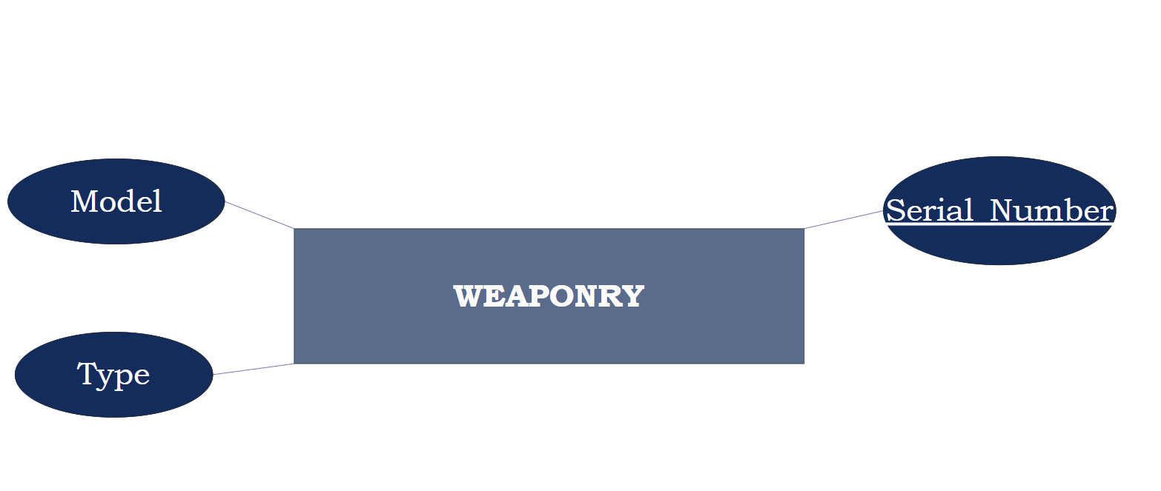

StarkSafe is well-known for its advanced weaponry, for it is shipped directly from Stark Industries. The WEAPONRY entity type can be uniquely identified by the key attribute Serial_Number, ensuring weapons don't get mixed up at the armory potluck. The **Type** attribute indicates the type of weaponry used, whereas the **Model** attribute specifies the model of the given weapon as specified by our beloved (and egotistical) Stark. Most of our destructive weaponry lurk in the shadows until the day calls for their formidable presence.

## POLICE_CAR

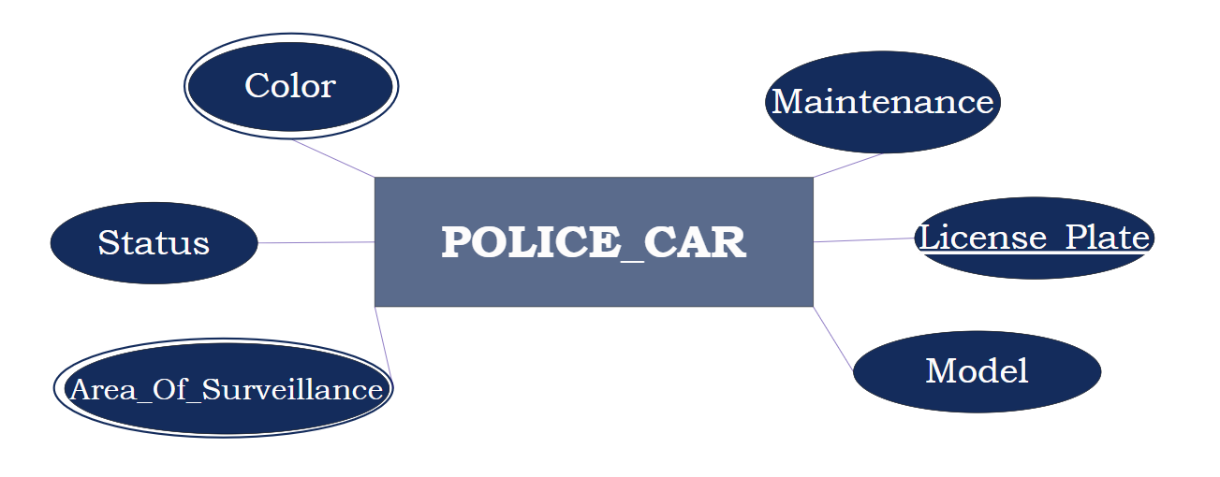

If you are walking in the afternoon on the road and suddenly hear a siren, don’t be afraid (unless you’re a criminal!) A POLICE_CAR is probably chasing a criminal to ensure the safety of you and everyone in the city. These engines are also used for traffic enforcement and monitoring. This entity type can be identified by a unique License Plate which is a key attribute. POLICE_CAR has other attributes such as **Status** that shows if the car is in use or not, **Maintenance** that provides the history of the car’s maintenance and its service cost, and **Model** which represents the model of the car. In addition, POLICE_CAR also has 2 multivalued attributes which are **Color** indicating the color(s) of the car, and **Area_Of_Surveillance** specifying the location(s) where the car operates.

## POLICE_DOG

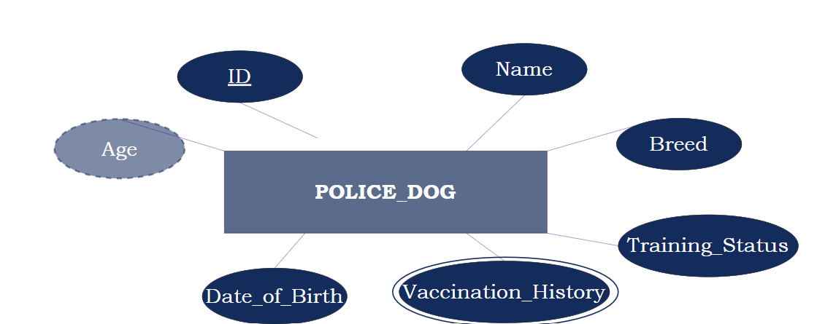

Think of Paw Patrol, but a hundred times more adventurous. Our furry four-legged officers have a lot to offer when it comes to fighting crime. The key attribute ID identifies the POLICE_DOG entity type, for it holds a unique identification number of the police dog (because they’re special too). This entity type also keeps track of the dog’s **Name** which, in this case, is their badge of honor. The **Date_Of_Birth** attribute logs information about the date our dogs came to life. The **Age** attribute, which is derived from **Date_Of_Birth,** helps us get an idea on how long our dogs have lived (and how long they may have left). In Addition, this entity type entails the dog's **Breed**, ranging between endless pawsibilities. And do not let the adorable face trick you because our dogs are not only fit to chase balls, but also to run after the bad guys thanks to the rigorous training they endure, maintained by the **Training_Status** attribute. The **Vaccination_History** indicates information about immunization shots in order to keep our dogs in tip-top shape and protected from any ruff situation.

## INSURANCE

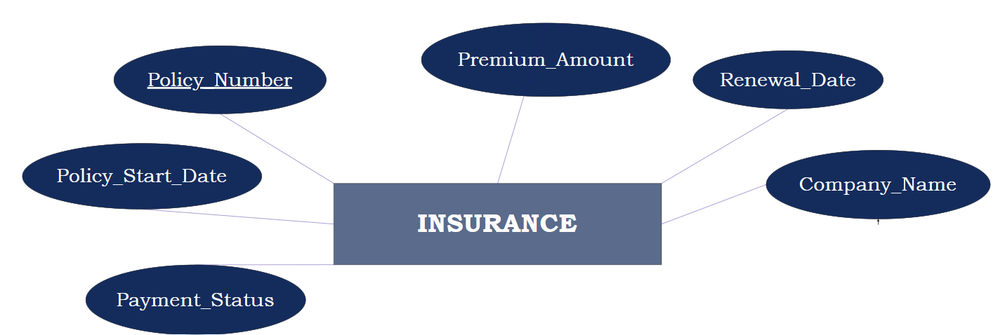

Stark thought his machines were too good to be ensured. That's until he lost a few million dollars on one of his “ground-breaking” projects. Now, every piece of flesh and metal associated with StarkIndustries has to be ensured. This entity type can be identified by an 8-digit unique Policy_Number, which is a key attribute. **Policy_Start_Date** specifies when the policy was first issued and went into safeguarding action. On the other hand, **Renewal_Date** indicates the date when the policy has to be re-established so that no one (and nothing) remains unprotected at StarkSafe. It’s just like an anniversary when you decide if you want to ditch the relationship or keep going. **Company_Name** specifies the name of the insurance company. Moreover, **Payment_Satus** indicates whether the insurance is paid or not. Finally, **Premium_Amount** specifies the amount of money to be paid. This guarantees that INSURANCE has our back “covered” when things go sideways.

## CRIMINAL

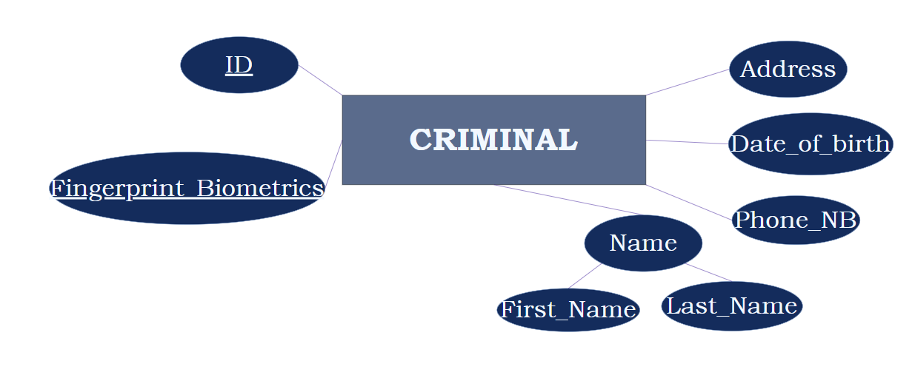

Any CRIMINAL roaming the city gets no time to enjoy their crimes as they are directly identified and detained by the police. Such people have their ID as well as their Fingerprint_Biometrics which is characterized by an 11-digit number that is unique to each individual pertained by scanning the measurements of their biometrics (Stark thought it wouldn’t be space-efficient to store the actual fingerprints). Both of these are unique keys to the entity type. These lowlifes, calling them that of course if their crimes were heinous, have several attributes such as the **Name**, which is composite and divided into **First_Name** and **Last_Name**. They have an **Address** to describe their place of residency as well as their **Phone_NB**. Finally, they have a **Date_of_birth** attribute that specifies the date when evil was born.

## CRIME_CASE

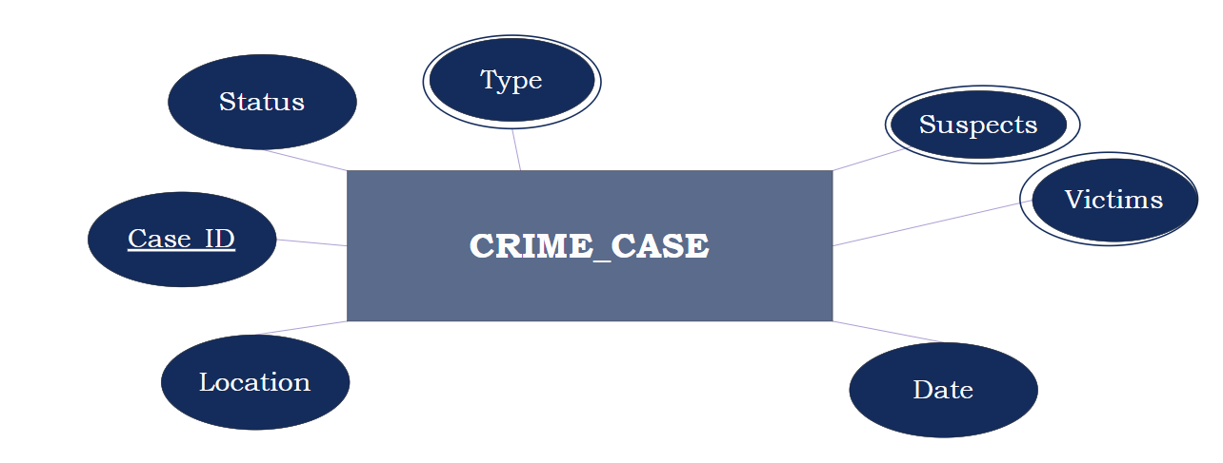

The CRIME_CASE is the result of the criminals’ evildoings. This entity type is identified by its primary key CASE_ID. There are other attributes such as the multivalued attribute **Type**, which could range from an innocent parking violation to a dangerous bank heist or even murder. Because criminals are nothing short of creative when committing their crimes, this attribute is multivalued (the number of arson and theft crimes is ridiculous). Of course, each CRIME_CASE has its **Location** where it was committed as well as the **Date**. There is also the **Status** attribute that states whether the CRIME_CASEis being investigated, is closed, or has unfortunately gone cold. Sometimes, the perpetrator hasn’t been directly identified, which is where the **Suspects** attribute comes into play to mention the names of those who might have committed the CRIME_CASE**.** The **Victims** attribute describes those who have been affected by the nefarious actions. Thus, the last two attributes are multivalued.

## 

## CRIMINAL_RECORD

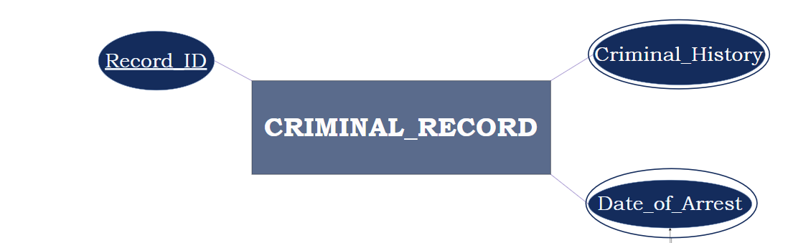

At StarkSafe, every shenanigan of a criminal is logged through our CRIMINAL_RECORD entity type. From small-time law-breakers to big-time supervillains, this entity type describes the deeds (or should I say misdeeds) of wrong-doers just like a top-secret archive from a crime-fighting comic. Along with a key attribute, Record ID, that helps us keep track of who’s who in a world of chaos and mayhem, the CRIMINAL_RECORD entity type stores the multivalued attributes **Date_of_arrest** of the criminal as well as the **Criminal_history** which specifies prior charges, warrants, and other criminal activities associated with the criminal.

## EVIDENCE

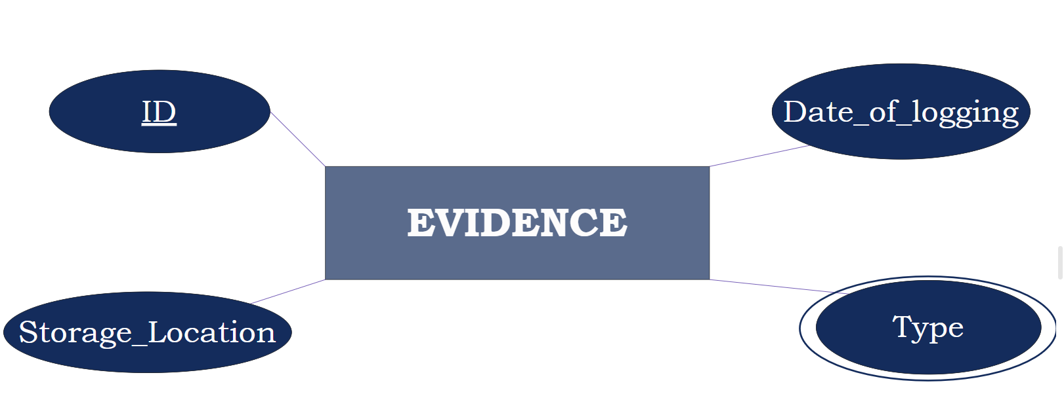

No crime is perfect! Even the craftiest criminals are bound to leave behind EVIDENCE. The EVIDENCE entity type can be identified by its key attribute ID, serving as a unique tag for every piece of evidence. The **Storage_Location** attribute specifies the location where the evidence is stored And the **Date_of_logging** indicates when it first stepped into StarkSafe. The cool part is that EVIDENCE comes in all sorts of types – like physical objects, papers, or even stories from witnesses, and this is logged by the multi-valued attribute **Type**.

## CELL

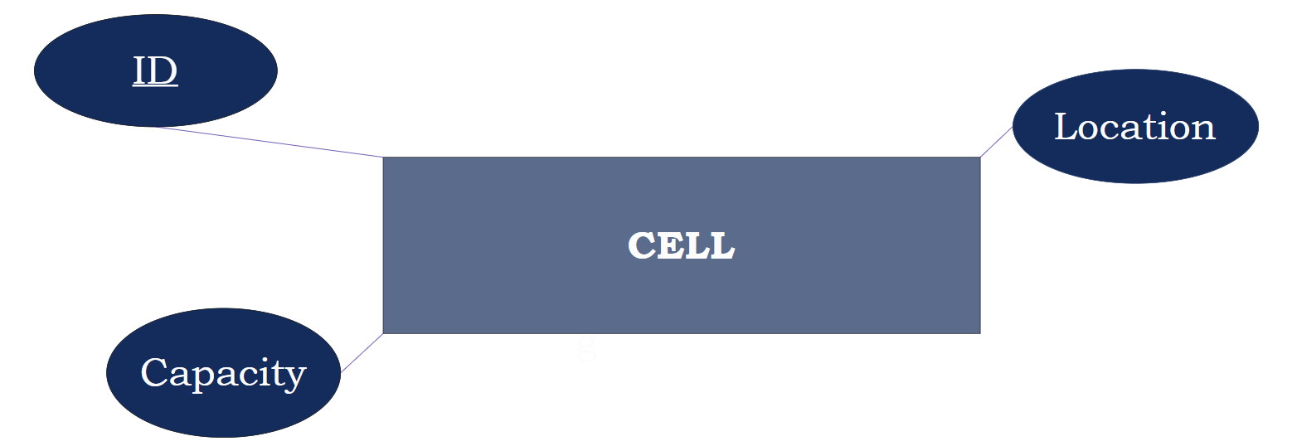

The CELL is the place where malicious criminals are kept temporarily. These rooms are identified with their primary key, the ID, and only have two other attributes: the **Location** of the CELL within the police station, as well as the **Capacity** of each room. Hopefully, a good amount of the criminals could be claustrophobic as these rooms surely won’t be spacious and comfortable, making them hope their actions were done in Norway (someone at StarkIndustries suggested outdoor cells…he’s fired).

# Relationships

## Works_In (Employee, Unit)

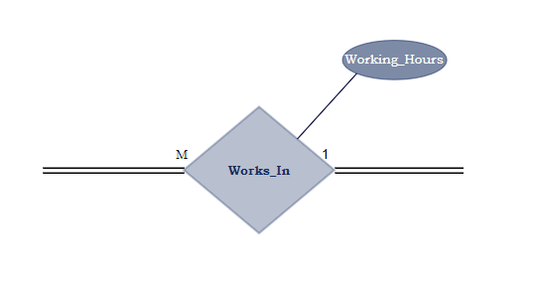

Each EMPLOYEE must work in a certain UNIT. Consequently, a “Works_In” relationship has to be created between EMPLOYEE on one hand and UNIT on the other. The relationship is **many-to-one** between EMPLOYEE and UNIT. Each EMPLOYEE works in one UNIT, and each UNIT can include one or more EMPLOYEEs. The participation is **total** on both ends since all EMPLOYEEs must work in UNITs, and each UNIT must have an EMPLOYEE working in it. The relationship “Works_in” has one attribute: **Working_Hours**. This attribute specifies the number of hours the employee has worked.

## Assigned_To (Unit, Robot Employee)

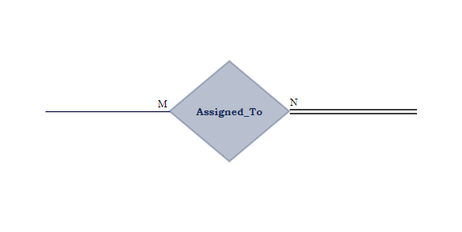

Our robot employees deliver their services very efficiently and accurately, helping us to automate many mundane tasks in all of our units at StarkSafe. Thus, a relationship “Assigned_To” has to be created between ROBOT_EMPLOYEE and UNIT. The relationship is **many-to-many**, meaning that one UNIT can have many ROBOT_EMPLPOYEEs and a single ROBOT_EMPLOYEE can be part of different UNITs. This relationship is **partial** on the UNIT’s end and **total** on the ROBOT_EMPLOYEE’s end since it's a rule that every ROBOT_EMPLOYEE should belong to at least one UNIT. However, not every UNIT is required to have a ROBOT_EMPLOYEE as it may have only human employees and no robot employees assigned to them.

## Instructs (Training Program, Robot Employee)

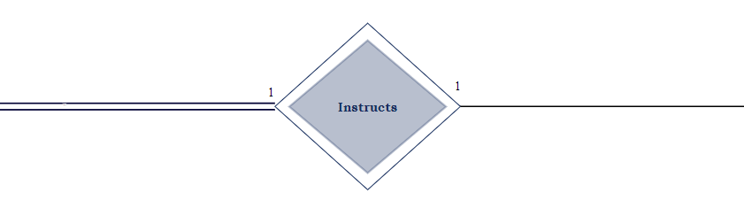

Each robot employee plays the vital role of taking on the responsibility of instructing various training programs to ensure our soldiers are receiving the best courses out there. For this reason, an “Instructs” identifying relationship has to be created between ROBOT_EMPLOYEE and TRAINING_PROGRAM. The relationship is **one-to-one** which means that each ROBOT_EMPLOYEE specializes in one TRAINING_PROGRAM, and each TRAINING_PROGRAM is given by only one robot. Hence, an identifying relationship between the two is established (if we have the resources, thanks to Stark of course, why not identify each program by its robot instructor?) The participation is **total** on the TRAINING_PROGRAM’s end and **partial** on the other end. This indicates that while not every ROBOT_EMPLOYEE is required to be an instructor, it is mandatory for each TRAINING_PROGRAM to have one ROBOT_EMPLOYEE as an instructor.

## Participates_In (Employee, Training Program)

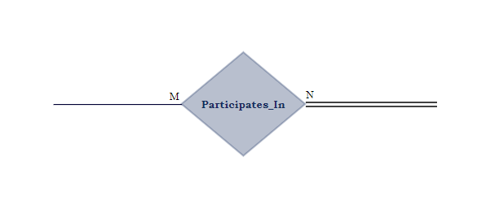

Most EMPLOYEEs have to be currently participating in certain TRAINING_PROGRAMs to acquire essential skills related to their positions and tasks. Thus, the relationship “Participates_in” is created between EMPLOYEE and TRAINING_PROGRAM. This relationship is **many-to-many** as each EMPLOYEE may be part of several programs, and each TRAINING_PROGRAM can hold many EMPLOYEEs too. The relationship is **partial** from the EMPLOYEE’s side as not all of them are always required to be a part of a program if previous training has been done, but it is **total** from the TRAINING_PROGRAM’s side as it wouldn’t exist if no participants are present.

## Prerequisites

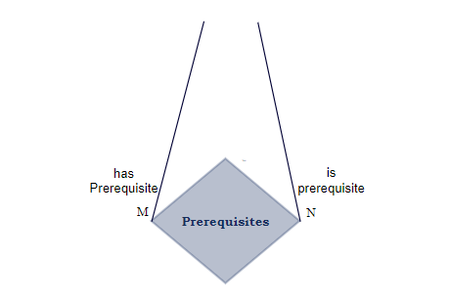

Not all TRAINING_PROGRAMS at StarkSafe are beginner-friendly, some may require prerequisite programs. Consequently, a self-referencing relationship “Prerequisites” has to be created for the TRAINING_PROGRAM entity type. This relationship is **many-to-many** because one TRAINING_PROGRAM can be a prerequisite to multiple other programs, and each program can require more than one prerequisite TRAINING_PROGRAM. It is **partial** on both sides since a training program doesn’t always require a prerequisite program and doesn’t need to be one for others as well.

## Has (Employee, Police Camera)

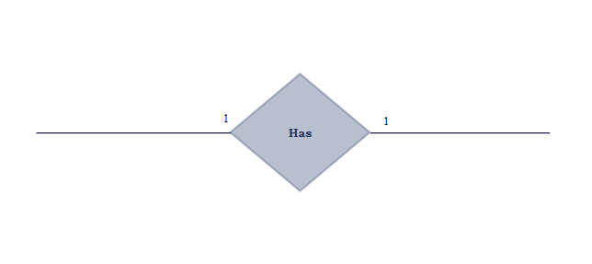An EMPLOYEE can own a POLICE_CAMERA during their investigation. So, a “Has” relationship must be created between these two entity types. This relationship is **one-to-one** since every EMPLOYEE can only own one POLICE_CAMERA, and each POLICER_CAMERA belongs to one EMPLOYEE. It is **partial** on both sides since not every employee has to own a POLICE_CAMERA, and not every camera belongs to an EMPLOYEE.

## Carries (Employee, Weaponry)



An “EMPLOYEE” may be required to carry a “WEAPONRY” when the job demands it, shaping the “Carries” relationship. In this context, it's a **one-to-one** relationship indicating that each EMPLOYEE is designated to carry oneWEAPONRY, and each WEAPONRY is exclusively assigned to one EMPLOYEE. This relationship is **partial** on both ends which means that not every EMPLOYEE is obligated to carry a weapon, and not every WEAPONRY is necessarily assigned to an employee. This approach ensures that firearms are provided solely to EMPLOYEEs who require them for their specific roles, in alignment with our commitment to safety and security.

## Drives (Employee, Car)

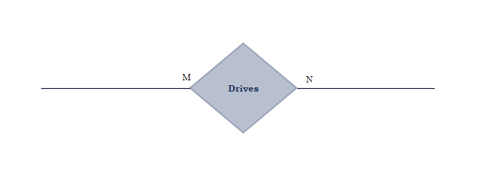

Police cars are a major part of a police station, and they are driven by employees. So, a “Drives” relationship has to be created between EMPLOYEE and POLICE_CAR. The relationship is **many-to-many** between EMPLOYEE and POLICE_CAR. Each EMPLOYEE can drive several POLICE_CARs, and each POLICE_CAR can be used by one or more EMPLOYEEs. The participation is **partial** on both ends because not all employees drive police cars, and some cars might be kept in storage without being used.

## Trains (Employee, Dog)

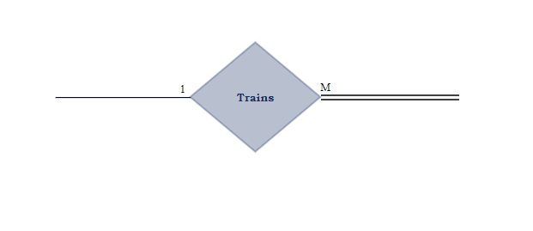

At StarkSafe, dogs make up a huge part of our everyday lives, for they are not only our closest companions, but they are also indispensable crime-fighting assets. Consequently, a “Trains” relationship has to be created between EMPLOYEE and POLICE_DOG. In this context, it's **one-to-many** which signifies that each EMPLOYEE can train multiple POLICE_DOGs, and each POLICE_DOG is trained by a single EMPLOYEE. The relationship is **partial** on the EMPLOYEE’s end and **total** on the POLICE_DOG’s end, meaning that while not every EMPLOYEEis obliged to train a POLICE_DOG, it is mandatory for each POLICE_DOG to receive training from an EMPLOYEE.

## Covers

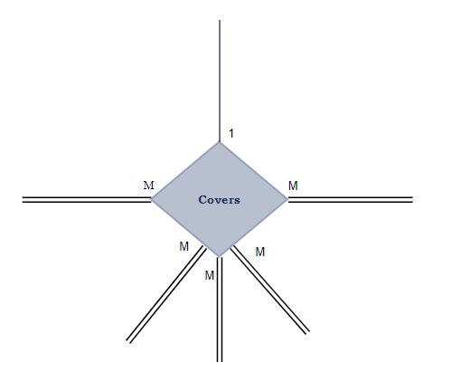

Several different entity types must be covered by an INSURANCE at our Police station (we have to avoid another multimillion loss of course). Therefore, a “Covers” N-ary relationship has to be created between INSURANCE on one hand and POLICE_CAR, POLICE_CAMERA, EMPLOYEE, POLICE_DOG, and ROBOT_EMPLOYEE on the other. The relationship is **one-to-many** between INSURANCE and all other entity types it covers. For simplicity, we are going to tackle INSURANCE and EMPLOYEE. Each INSURANCE can cover many EMPLOYEEs, and each EMPLOYEE is covered by one INSURANCE. The participation is **partial** on the INSURANCE’s end, whereas it is **total** on the EMPLOYEE's end because all EMPLOYEEs are covered by INSURANCE, however not all INSURANCE policies cover EMPLOYEEs.

## Has (Criminal, Crime)

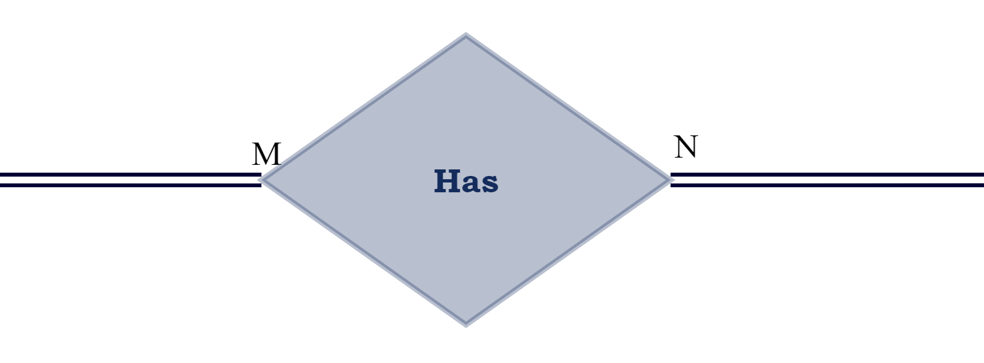

What makes a person a CRIMINAL is the CRIME that they have done. Thus, the relation “Has” fits as a relationship between CRIMINAL and CRIME. This relationship is many-to-many as each CRIME may be committed by several CRIMINALs, and one CRIMINAL can commit several CRIMEs. It is also total from both sides since as mentioned before, a CRIMINAL isn’t one unless a CRIME is committed, and a CRIME is not done by someone other than a CRIMINAL.

## Investigates (Employee, Crime Scene)

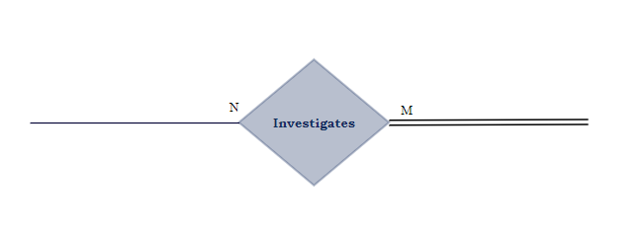

Every CRIME_SCENE should be investigated by an EMPLOYEE (literally their job). This is why a relationship “Investigates” is established between CRIME_SCENE and EMPLOYEE. This relationship is **many-to-many** because multiple employees can investigate one crime scene, and many crime scenes can be investigated by only one employee (they’ve probably taken on way too many). This relationship is **partial** from the EMPLOYEE side since not every employee investigates a crime scene (you have to be top-tier, it's serious stuff), but it is **total** on the CRIME_SCENE’s side since every crime scene should be investigated by an employee.

## Has (Evidence, Crime Case)

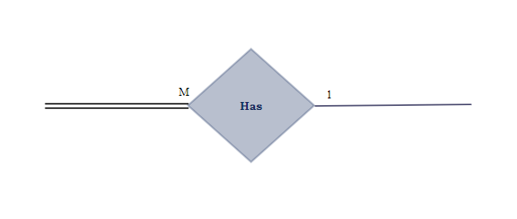

Almost all CRIME_CASEs have EVIDENCE, thus a “Has” relationship is created between CRIME_CASE and EVIDENCE to help us keep track of everything. This relationship is **one-to-many** between CRIME_CASE and EVIDENCE. Each CRIME_CASE may have one or more EVIDENCE, but a single piece of EVIDENCE can be traced back to only one CRIME_CASE. This relationship is **partial** on the CRIME_CASE’s side since not all crime cases have EVIDENCE, but it’s **total** from the EVIDENCE’s side since all evidence must belong to a CRIME_CASE.

## Associated with (Criminal, Criminal Record)

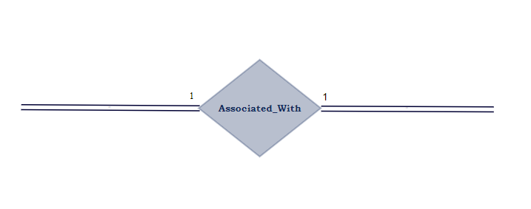

Each CRIMINAL has a CRIMINAL_RECORD that contains information about the CRIME and previous ones if present. Therefore, a relation “Associated_with” is created between CRIMINAL and CRIMINAL_RECORD which is a **one-to-one** as each CRIMINAL has only one CRIMINAL_RECORD and vice versa. This relationship is **total** on both sides since all CRIMINALs must have CRIMINAL_RECORDs and all these records belong to CRIMINALs.

## Guards

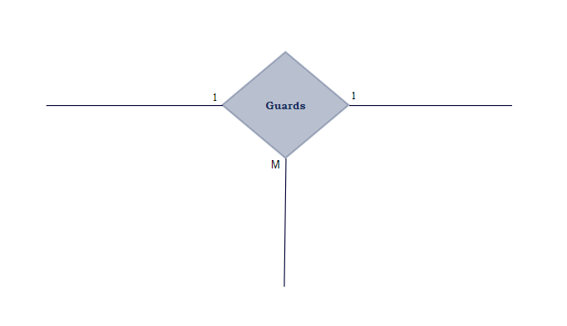Cells at StarkSafe must be guarded by either our EMPLOYEE or ROBOT_EMPLOYEE. Therefore, a “Guards” ternary relationship has to be created between EMPLOYEE/ROBOT_EMPLOYEE and CELL. The relationship is **one-to-many** between EMPLOYEE/ROBOT_EMPLOYEE and CELL. Each EMPLOYEE guards one or more CELLs, and each CELL is guarded by one EMPLOYEE. The participation is **partial** on both ends because not all employees guard cells, and some cells might be empty and do not need to be guarded.

## Occupies (Criminal, Cell)

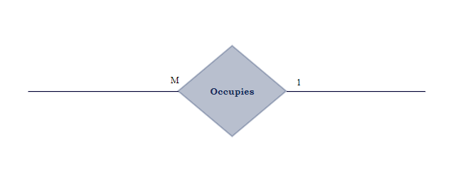

A good amount of CRIMINALs are put in the CELLs temporarily. And so, a relationship “Occupies” exists between CRIMINAL and CELL. The relationship is **many-to-one** as several CRIMINALs may be put in the same CELL if there is capacity. It is also **partial** from both sides as not all CRIMINALs are put in CELLs, especially if the offense was minor such as a traffic fine, and not all CELLs are always filled.

# 

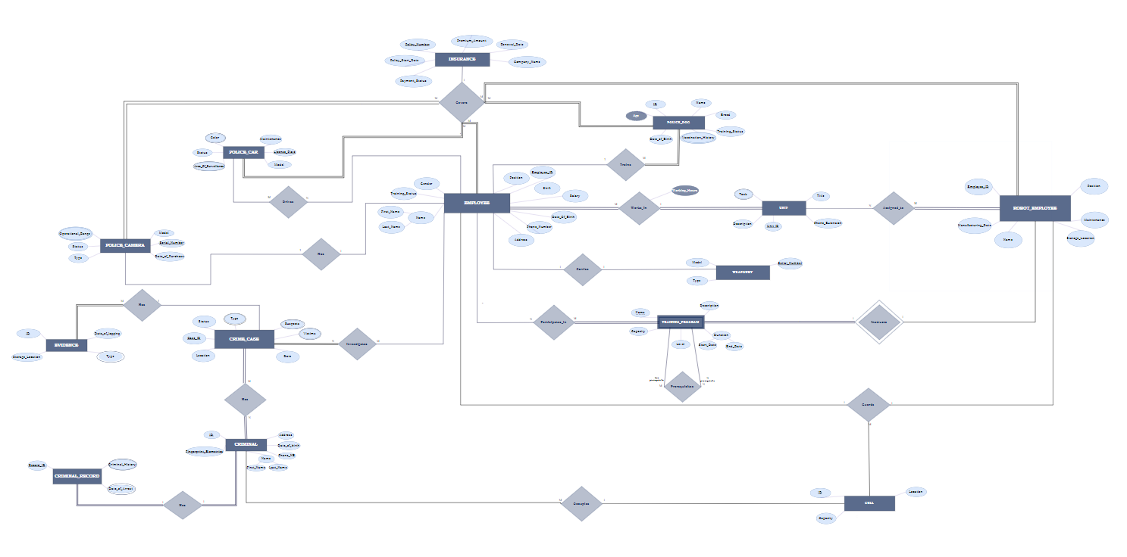

1. ER To Relational Mapping Algorithms

# Step 1 - Mapping Of Regular Entity Types

In the first step, the strong entity types are going to be mapped into relations. Each regular entity type is going to be represented by a relation that includes simple attributes and a single underlined **primary key**. The strong entity types in this database design for StarkSafe police station are **EMPLOYEE, UNIT, ROBOT_EMPLOYEE, WEAPONRY, TRAINING_PROGRAM, CELL, POLICE_DOG, INSURANCE, POLICE_CAR, POLICE_CAMERA, CRIMINAL, CRIME_CASE,** and **CRIMINAL_RECORD, EVIDENCE.**

## EMPLOYEE



The EMPLOYEE is the entity type that is most valuable to StarkSafe Police Station. Hence, we keep as much information about our employees as possible. It contains the primary key **Employee_ID**, and the composite attribute Name, which contains the attributes **First_Name** and **Last_Name**. The entity type also includes the following simple attributes: **Gender, Date_Of_Birth, Position, Training_Status, Shift, Address, Phone_Number,** and **Salary**.

## 

## ROBOT_EMPLOYEE

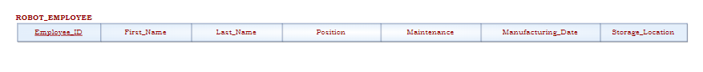

The ROBOT_EMPLOYEE entity type contains simple attributes only. Similarly, the relation ROBOT_EMPLOYEE includes all these simple attributes. The primary key for this relation is **Employee_ID**. The other attributes are **First_Name**, **Last_Name**, **Position**, **Maintenance**, **Manufacturing_Date**, and **Storage_Location**.

## UNIT

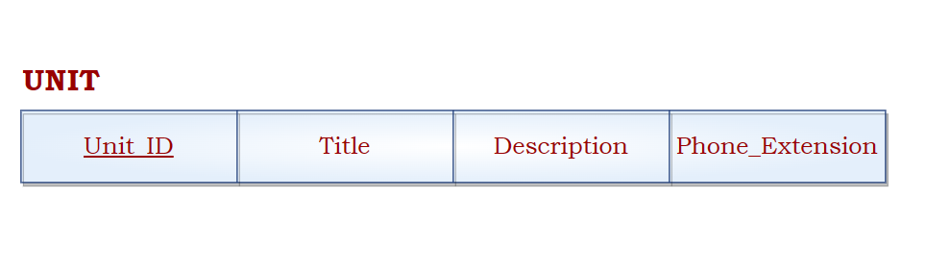

UNIT is an indispensable entity type that contains both simple and multi-valued attributes.**Unit_ID** is chosen to serve as a primary key for this relation. The other three simple attributes represented in this relation are **Title**, **Description**, and **Phone_Extension**. The multi-valued attribute *Task* is going to be mapped in Step 6.

## POLICE_CAMERA

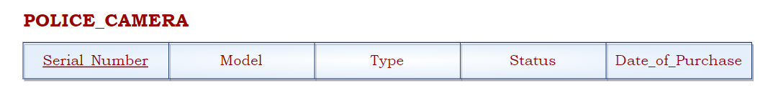

The POLICE_CAMERA entity type contains simple and multivalued attributes. The multivalued attribute *Operational_Range* will not be included in this relation. This relation only includes the simple attributes **Model**, **Status**, **Type**, **Date_Of_Purchase,** and the underlined primary key **Serial_Number**.

## WEAPONRY

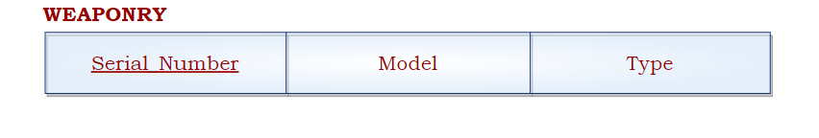

Keeping track of our weaponry stock is essential to make sure it never goes into the wrong hands. Thus, the WEAPONRY entity type consists of simple attributes only. **Serial_Number** serves as the primary key of this relation. The remaining attributes, which are simple, are **Model** and **Type**.

## POLICE_CAR

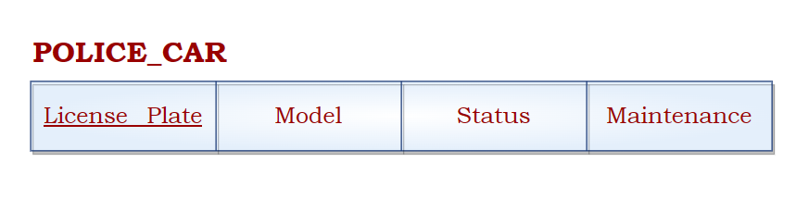

The POLICE_CAR entity type contains both simple and multi-valued attributes. The relation consists of the simple attributes only which are **Model**, **Status**, **Maintenance**. **License_plate** serves as a primary key for this relation. The multi-valued attributes *Color* and *Area_Of_Surveillance* will be mapped in Step 6.

## POLICE_DOG

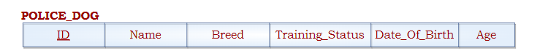

The POLICE_DOG entity type is our best friend. The primary key, **ID**, gives us a way to identify our furry friends. That is because some of them share the same name. Hence, the entity type also has the following simple attributes: **Name, Breed, Training_Status,**  **Date_Of_Birth**, and the derived attribute **Age**.

## 

## INSURANCE

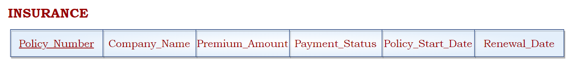

The INSURANCE is the entity type that has everyone and everything else covered. The entity type contains simple attributes only. Consequently, the relation INSURANCE includes all of these simple attributes. It is defined with a primary key **Policy_Number**. The remaining simple (they’re actually super complicated) attributes are: **Company_Name**, **Premium_Amount, Payment_Status, Policy_Start_Date,** and **Renewal_Date**.

## CRIMINAL



The CRIMINAL entity type includes both simple and composite attributes. The composite attribute **Name** consists of two simple attributes **First_Name** and **Last_name**. The relation CRIMINAL therefore includes all of these simple attributes. Out of the two key attributes of this entity type, we have chosen the primary key to be **ID** , leaving **Fingerprint_Biometrics** to be a candidate key.This relation also contains other simple attributes: **Address**, **Date_Of_Birth**, **Phone_NB** ,

## CRIME_CASE

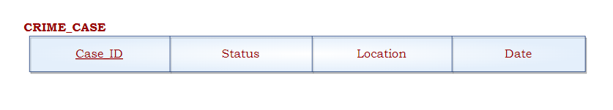The CRIME_CASE entity type contains both simple and multi-valued attributes. The attribute **CASE_ID** serves as the primary key for this relation. The other simple attributes are **Status**, **Location**, and **Date**. The multi-valued attributes of the entity type are *Type, Suspects,* and *Victims*which are going to be mapped in Step 6.

## CRIMINAL_RECORD

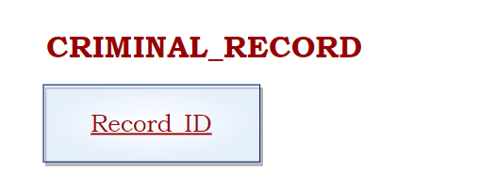

The CRIMINAL_RECORD entity type helps our officers keep track of criminals’ history. The **Record_ID** which serves as the primary key, helps our officers track the documents efficiently. Because such documents could never be simple, this entity type lacks simple attributes. However, it has 2 multivalued attributes, *Date_Of_Arrest* and *Criminal_History,* that will be displayed in later steps.

## EVIDENCE

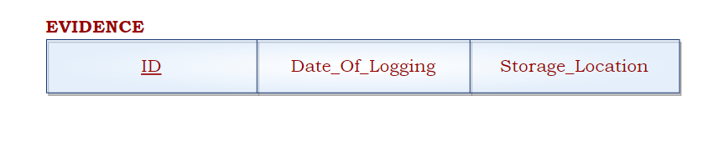

The EVIDENCE entity type consists of both simple and multi-valued attributes. However, the relation EVIDENCE includes only the simple attributes. The primary key of this relation is **ID**. Besides, the other simple attributes of the relation are **Date_Of_Logging** and **Storage_Location**. The multi-valued attribute of the entity type is *Type* which is going to be mapped in Step 6.

## CELL

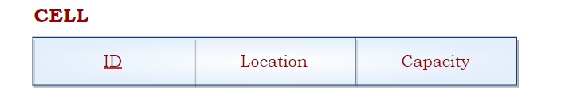

To help our officers keep track of the logistics of criminal cells, the CELL entity type is formed. Consequently, the CELL relation consists of simple attributes only. It has a primary key **ID**. It also has two other simple attributes: **Location** and **Capacity**.

# Step 2 - Mapping Of Weak Entity Types

Onwards with Step 2. This is where weak entity types are mapped into relations (because in our city, nothing remains weak). Similar to the previous step, only the simple attributes are included without the multivalued and derived ones. Weak entity type relations have foreign keys which are the primary keys of other entity types. And so, the primary keys of the relations consist of the foreign key from the other entity type and the partial key of the weak entity type. In our database, the only weak entity type is TRAINING_PROGRAM. (P.S nothing is weak at StarkSafe, but apparently, Stark’s professor, Dr. Ramzi Haraty, claims that *every database must have a weak entity type.* So we complied.)

## 

## TRAINING_PROGRAM



The TRAINING_PROGRAM is a weak entity type that contains both simple and composite attributes. The composite attribute **Duration** is made up of two simple attributes **Start_Date** and **End_Date**. The remaining simple attributes are **Description**, **Capacity**, **Level,** and **Name**. All these simple attributes are included in the relation. The partial key *Name* along with the primary key of the ROBOT_EMPLOYEE **R_EmployeeID** serve as the primary key of the TRAINING_PROGRAM relation.

# Step 3 - Mapping of 1:1 Binary Relation Types

Jumping to the third step, the mapping of binary one-to-one relationships is done. There are several approaches to this mapping. The first is the foreign key approach. Here, the entity on the total participation side of the relationship is chosen to carry the primary key of the other participating entity as a foreign key. The second, the merged relation approach is where two entity types are merged into one. The third and final, cross-reference, is one where we create a third relation containing the primary keys of both entity types. This step was completed using the foreign key approach as it was the most suitable (and recommended by Stark’s professor).

## EMPLOYEE (HAS)



The “Has” one-to-one relationship links the EMPLOYEE and POLICE_CAMERA. On both sides of the participating entities, the participation is partial. Thus, POLICE_CAMERA’s primary key is renamed **Cam_Serial_Num**  and added as a foreign key to the EMPLOYEE relation.

## 

## CRIMINAL_RECORD (HAS)

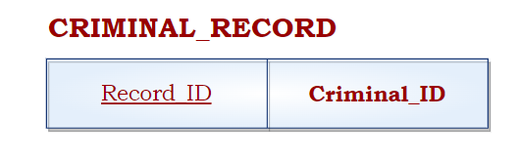

Every CRIMINAL has a CRIMINAL_RECORD, and so, the “Has” one-to-one relationship links CRIMINAL and CRIMINAL_RECORD. The relationship is total from both sides, meaning that it doesn’t matter where the foreign key is added. So, a foreign key, which is the primary key of the CRIMINAL relation, was added to the CRIMINAL_RECORD relation and renamed to **Criminal_ID**.

## WEAPONRY (CARRIES)

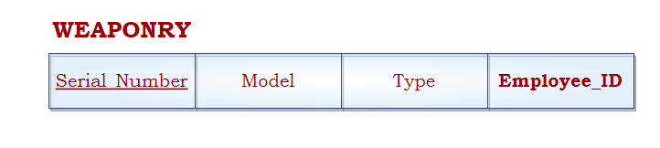

An EMPLOYEE might carry a weapon, which is why a “Carries” relationship linking EMPLOYEE and WEAPONRY was created. The relationship is partial on both sides. So, we chose to add the primary key of the EMPLOYEE**, Employee_ID,** as a foreign key in the relation WEAPONRY.

# 

# Step 4 - Mapping of 1:M Relationship Types

In this step, the One-To-Many relationships are going to be mapped. In case of a Partial-Total participation, the primary key of the relation of the Partial-side entity type is added as a foreign key to the relation of the Total-side entity type. This restriction is lifted in case of Total-Total or Partial-Partial participation. In addition, any simple attributes on the 1:M relationship must be added to the newly created relation. The One-To-Many relationships that need to be mapped are: **Trains, Works_In,**  **Occupies,** and **Has.**

# 

## EVIDENCE (HAS)

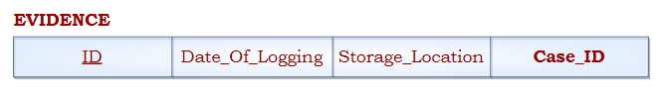

The many-to-one relationship “Has” links CRIME_CASE and EVIDENCE. The primary key of CRIME_CASE, **Case_ID,** is added to the EVIDENCE relation as a foreign key. This is due to EVIDENCE being on the many side of the relationship.

# 

## EMPLOYEE (WORKS IN)



The many-to-one relationship “Works In” links EMPLOYEE and UNIT. The relationship has its own attribute Working_Hours. Thus, **Working_Hours** is added to the EMPLOYEE relation. The UNIT’s primary key, **Unit_ID** is also added as a foreign key attribute.

## 

## POLICE_DOG (TRAINS)

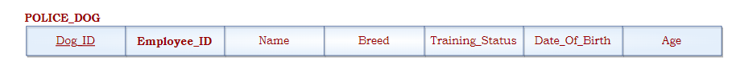

The “Trains” relationship connects the entity types POLICE_DOG and EMPLOYEE, as each employee trains a certain police dog. We added the **Employee_ID,** theprimary key attribute of EMPLOYEE, to the POLICE_DOG relation as a foreign key since it's on the “many” side of the relationship.

## CRIMINAL (OCCUPIES)



The “Occupies” relationship connects the entity types CRIMINAL and CELL, as many criminals could occupy a specific cell. So, we added the primary key of the CELL entity type **Cell_ID** to the CRIMINAL relation. This is due to CRIMINAL being on the ”many” side of the relationship.

## TRAINING_PROGRAM (INSTRUCTS)



An “instructs” many-to-one relationship exists between TRAINING_PROGRAM and ROBOT_EMPLOYEE. Since the primary key of ROBOT_EMPLOYEE is already present in the TRAINING_PROGRAM relation, then no changes are made.

# Step 5 - Mapping of M:N Relationship Type

In this stage, the mapping of many-to-many relationships will be done. Unlike previous steps, this step involves the creation of a new relation that incorporates the primary keys from all the involved entity types, serving as foreign keys. Together, these keys will be the primary key of the newly formed relation. In our database, the following many-to-many relationships will be mapped: **Assigned_To, Participates_In, Drives, Has, Investigates,** and **Prerequisites**

## HAS

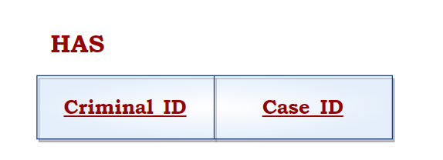

Each CRIME_CASE can have many CRIMINALs and vice-versa. So, a many-to-many relationship “Has” exists between the two entity types. Hence, the HAS relation is established with their primary keys: **Criminal_ID** and **Case_ID.** Together, they represent the primary key of the relation HAS.

## PARTICIPATES_IN

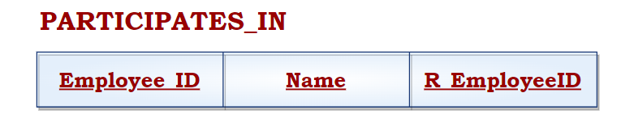

A many-to-many “Participates_In” relationship between the two entity types EMPLOYEE and TRAINING_PROGRAM is established. We created a new relation PARTICIPATES_IN which includes both the primary key of the EMPLOYEE **Employee_ID** and that of the TRAINING_PROGRAM (**Name**, **R_EmployeeID**). The combination of these two keys forms the primary key of this relation, and so both are underlined.

## ASSIGNED_TO

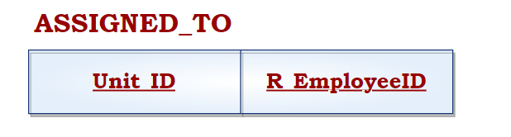

An “Assigned_To” many-to-many relationship links the two entity types UNIT and ROBOT_EMPLOYEE. After creating a new relation ASSIGNED_TO, the primary key of the relation UNIT, **Unit_ID**, is added along with the primary key of the relation ROBOT_EMPLOYEE, **R_EmployeeID,** as foreign keys that would together serve as a primary key for ASSIGNED_TO.

1. **INVESTIGATES**

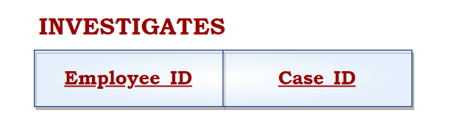

An “Investigates” many-to-many relationship links the two entity types EMPLOYEE and CRIME_CASE. Consequently, a new relation INVESTIGATES is created containing both the primary key of the EMPLOYEE relation, **Employee_ID,** as well as that of CRIME_CASE, **Case_ID**. The combination of these two keys forms the primary key of this relation, and so both are underlined.

## DRIVES

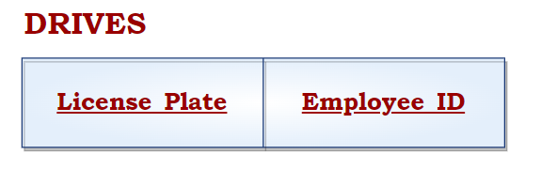

The “Drives” relationship links the EMPLOYEE entity type to POLICE_CAR entity type. So, a new relation DRIVES is created which includes the primary keys of both EMPLOYEE and POLICE_CAR. Together, both keys (**Employee_ID,** **License_Plate**) form the primary key of this relation, and so both are underlined.

1. **PREREQUISITES**

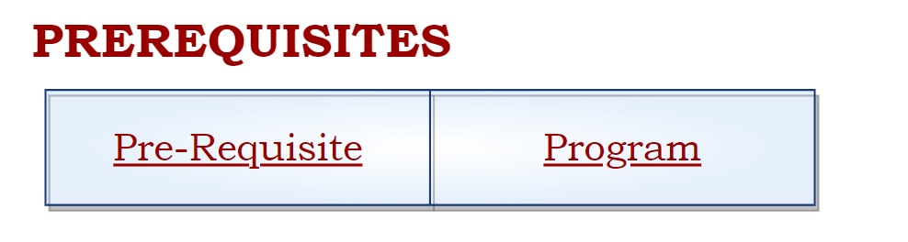

The “Prerequisites” relationship is a self-referencing relationship on the TRAINING_PROGRAM entity type. A new relation PREREQUISITES is created which includes the candidate key of both TRAINING_PROGRAMs. Together, both keys (**Pre-Requisite,** **Program**) form the primary key of this relation, hence both are underlined.

# Step 6- Mapping the Multivalued Attributes

In this step, the previously overlooked multivalued attributes will get their time to shine. For each multivalued attribute, a new relation will be established. The primary key of the relation will consist of the attribute relative to it and the primary key of the entity type to which it originally belonged. In our database, 6 multivalued attributes will be mapped: **Operational_Range, Color, Police_Car_Surveillance, Type, Victims,** and **Suspects.**

## CAM_RANGE

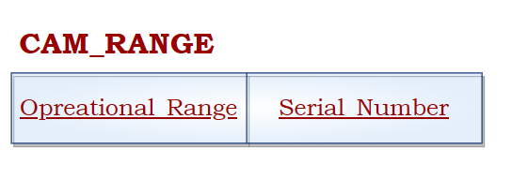

The entity type POLICE_CAMERA has a multivalued attribute **Operational_Range**. Consequently, a new relation CAM_RANGE is created. The relation’s primary key is a combination of the POLICE_CAMERA’s primary key **Serial_Number** and **Operational_Range**, the renamed multivalued attribute representing the different operational ranges a camera might have.

## CAR_COLOR

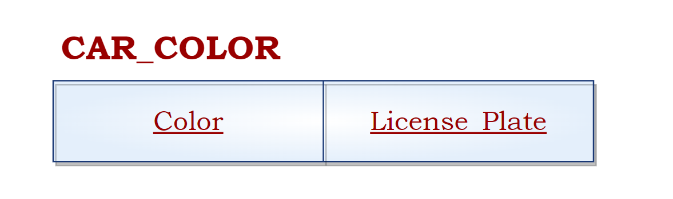

The entity type POLICE_CAR has a multivalued attribute **Color**. Thus, the relation CAR_COLOR was created to express the attribute. The relation’s primary key is a combination of the primary key of POLICE_CAR, **License_Plate**, and **Color**, the multivalued attribute representing the different colors a police car might have.

## POLICE_CAR_SURVEILLANCE

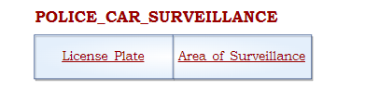

The entity type POLICE_CAR also has a multivalued attribute named **Area_of_Surveillance**. So, a relation POLICE_CAR_SURVEILLANCE was created to represent it. The primary key consists of **License_Plate**, the primary key of POLICE_CAR, and the attribute **Area_of_Surveillance** which represents the different areas a car is assigned for surveillance.

## CRIME_TYPE

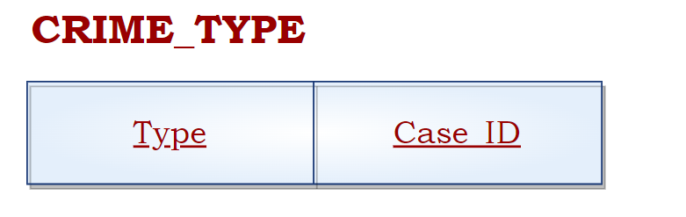

Since some crimes like to mix and match, our officers need to keep track of the different types of crimes done in one case. Thus, the multivalued attribute **Type** is found in the CRIME_CASE entity type. To represent it, a new relation has been created, named “CRIME_TYPE”. Its primary key is composed of the attribute **Type** and **Case_ID** which is the primary key of the CRIME_CASE relation.

## CRIME_VICTIMS

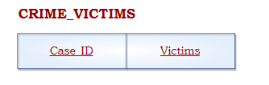

Our officers keep track of all the victims, to honor their memory, and inform their loved ones. Thus, the multivalued attribute **Victims** is also found in the CRIME_CASE entity type. A new relation CRIME_VICTIMS has been created to represent it. Together, the attribute **Victims** and **Case_ID**, the primary key of CRIME_CASE, represent the primary key of the newly created relation.

## 

## CRIME_SUSPECTS

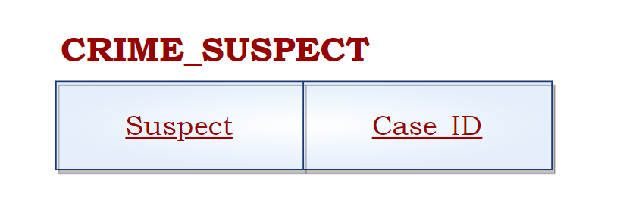

The multivalued attribute **Suspect** is also found in the CRIME_CASE entity type. A new relation CRIME_SUSPECT has been created to represent it. Together, the attributes **Suspect** and **Case_ID** represent the primary key of the newly created relation.

## 

## EVIDENCE_TYPE

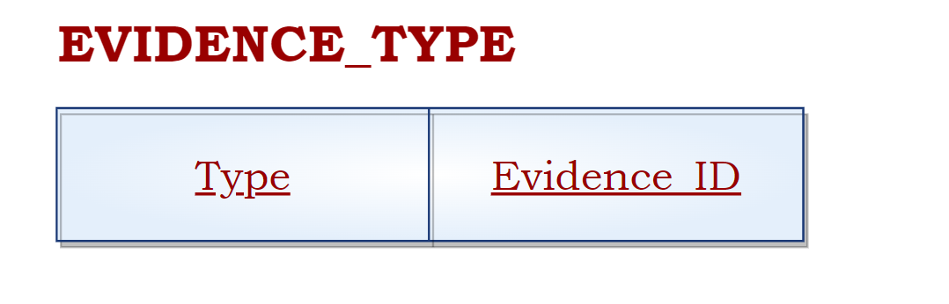

The entity type EVIDENCE has a multivalued attribute named **Type**. So, a relation EVIDENCE_TYPE was created to represent it. The primary key consists of **Evidence_ID**, the renamed primary key of EVIDENCE, and the attribute **Type** which represents the different types that one piece of evidence may be.

## RECORD_OF_ARREST

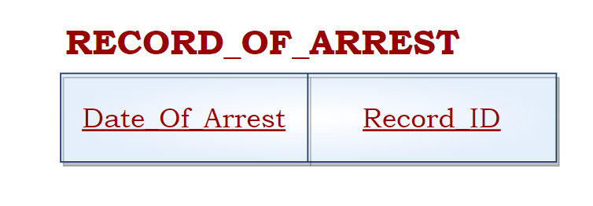

The entity type CRIMINAL_RECORD has a multivalued attribute named **Date_Of_Arrest**. So, a relation RECORD_OF_ARREST was created to represent it. The primary key consists of **Record_ID**, the renamed primary key of CRIMINAL_RECORD, and the attribute **Date_Of_Arrest** which represents the different arrest dates present in a certain criminal record.

## UNIT_TASK

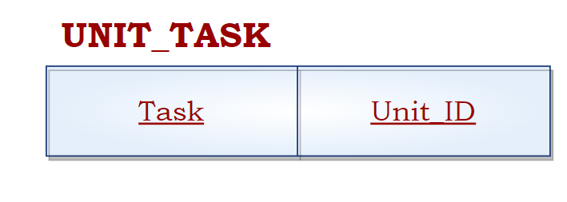

The multivalued attribute **Task** is found in the UNIT entity type. A new relation UNIT_TASK has been created to represent it. Together, the attribute **Task** and **Unit_ID** , the primary key of the entity type UNIT, represent the primary key of the newly created relation which lists the different tasks a unit may have.

## DOG_VACCINATION

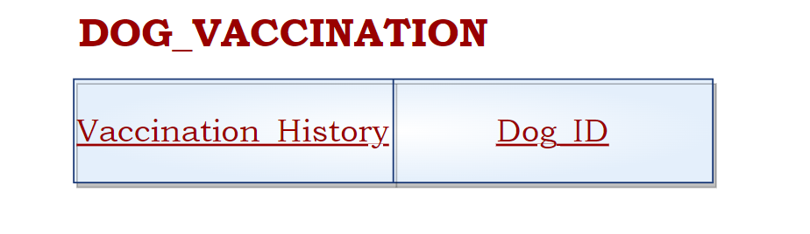

**Vaccination_History** is a multivalued attribute that belongs to the POLICE_DOG entity. It indicates the several vaccines that our furry fighters have done. The primary key in this relation is **Dog_ID**, which belongs to the POLICE_DOG and serves as its primary key, and the attribute **Vaccination_History**.

## CRIMINAL_HISTORY_RECORD

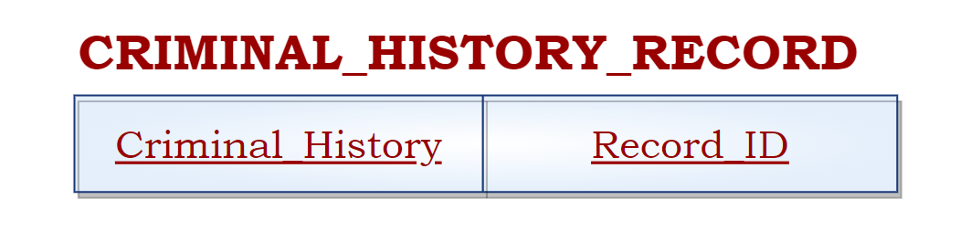

**Criminal_History** is a multivalued attribute that belongs to the CRIMINAL_RECORD entity. It indicates the several crimes that criminals may have done. The primary key in this relation is **Record_ID**, which belongs to the CRIMINAL_RECORD and serves as its primary key alongside the attribute **Criminal_History**.

# Step 7 - Mapping the N-ary Relationship Types

In this step, the N-ary Relationship types will be mapped. A new relation is created for each relationship. The primary key of the relation is the combination of all the primary keys of the participating entities. In our case, 2 N-ary relationships will be mapped: GUARDS and COVERS.

## GUARDS

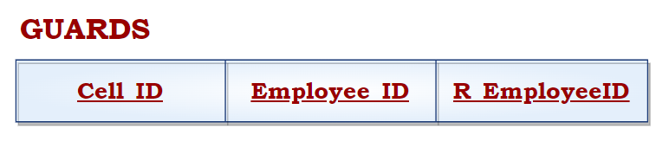

An N-ary relationship exists between ROBOT_EMPLOYEE, EMPLOYEE, and CELL. This relationship is mapped by a new relation GUARDS. The primary key is composed of each of the participating entities’ primary keys: **R_Employee_ID**, **Employee_ID**, and **Cell_ID.**

## COVERS

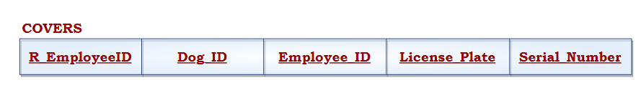

INSURANCE covers five different entity types : EMPLOYEE, ROBOT_EMPLOYEE, POLICE_CAR, POLICE_CAMERA, and POLICE_DOG. Therefore, we take the primary keys of each of those entity types’ relations and add it to a new relation COVERS. The primary keys are **Employee_ID**, **R_EmployeeID**, **License_Plate**, **Serial_Number**, and **Dog_ID** respectively. The relationship Covers does not have any simple attributes. It is worth noting that the primary key of POLICE_DOG (**ID**) was renamed to **Dog_ID**

Entity-Relational Model (Connections of Steps 1-2-3-4 + Final Display of Steps 5-6-7)

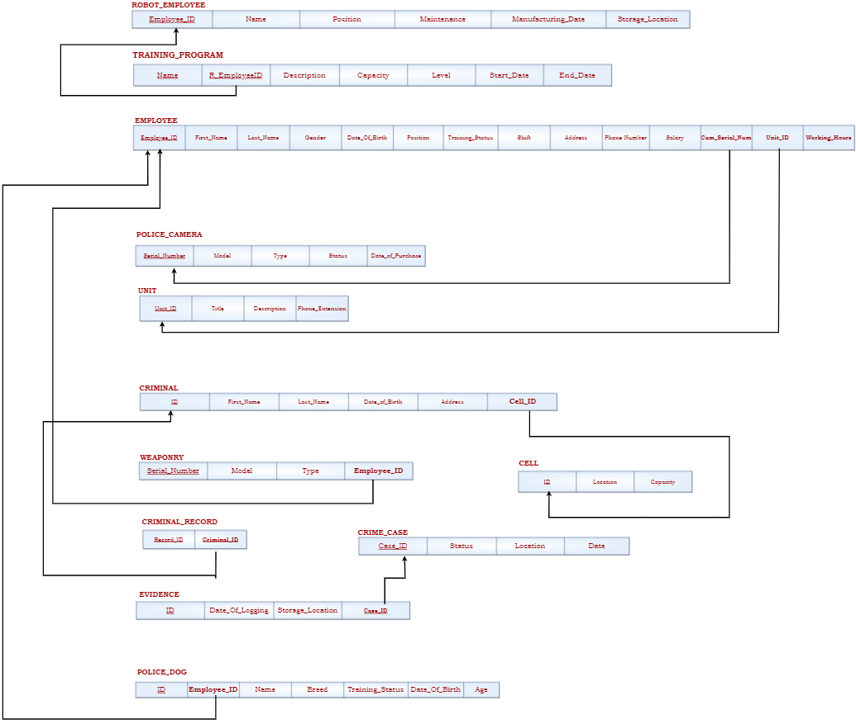

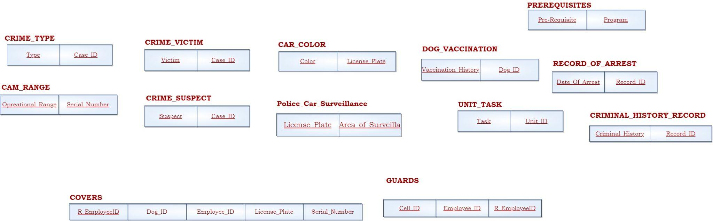

III. Translating into SQL

# Creating the Tables

After creating all entities, attributes, relationships, and relations, it is time to transform all that work into existence by coding it using SQL on the Oracle Database Server. First, we created tables corresponding to all the relations established. The meta-data, constraints, primary, and foreign keys were also specified.Then, we populated the tables by inserting the data. Finally, unique and meaningful queries were executed to reach and recognize vital patterns and statistics.

After the tables have been created, the description, or meta-data, of each table, can be viewed to provide a simplified version of the names, data types, default values, and primary and null statuses of the attributes.

**N.B:** Oracle 11g XE Server does not support the usage of “ON DELETE CASCADE ON UPDATE CASCADE’.

1. **Employee**

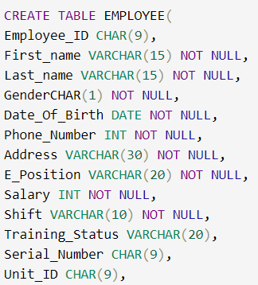

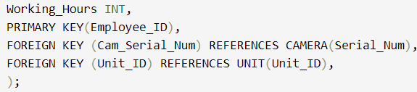

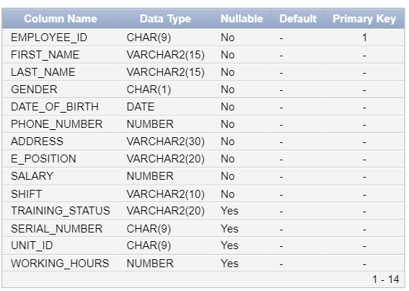

1. **Robot_Employee**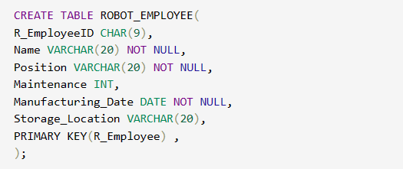

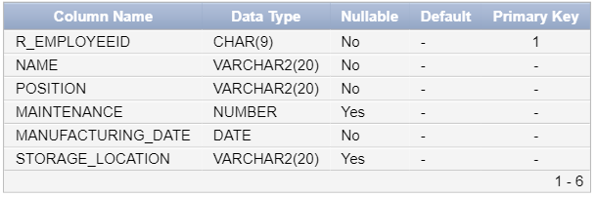

1. **Unit**

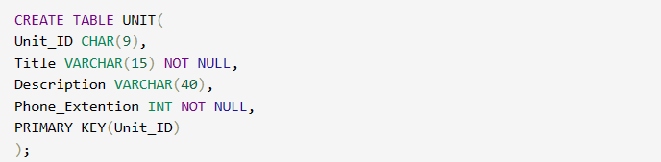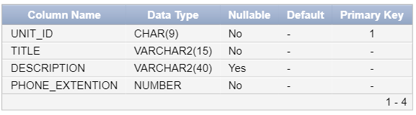

1. **Training_Program**

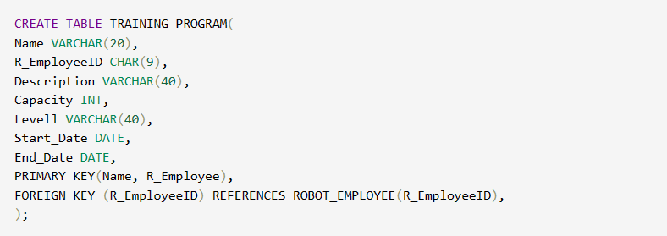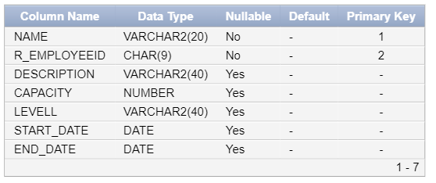

1. **Police_Dog**

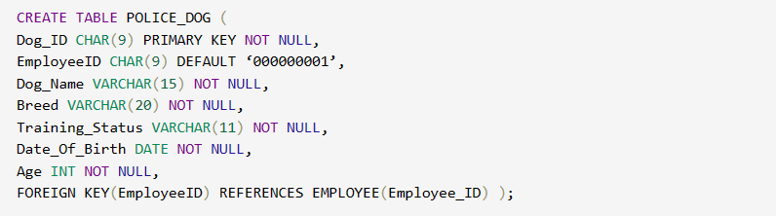

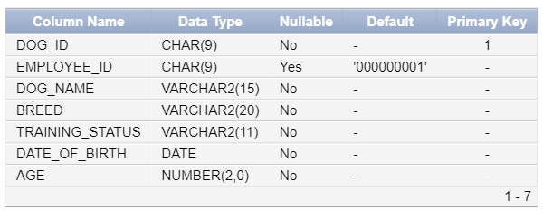

1. **Police_Car**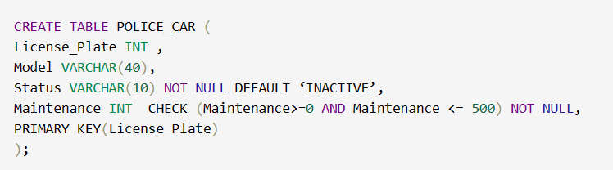

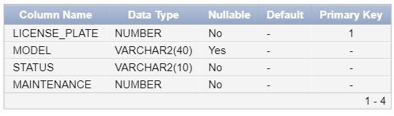

1. **Camera**

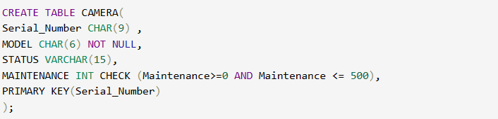

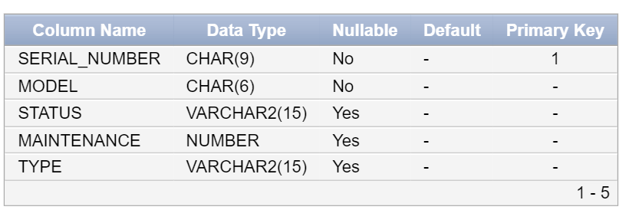

1. **Weaponry**

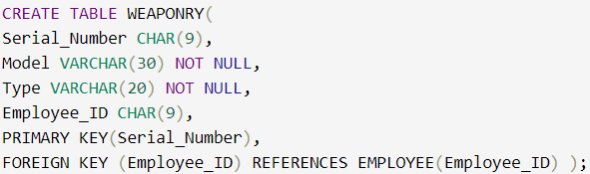

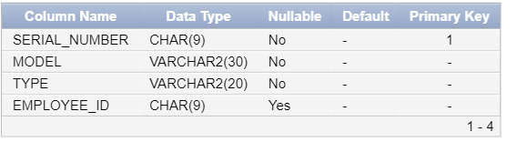

1. **Crime_Case**

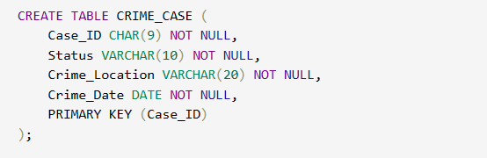

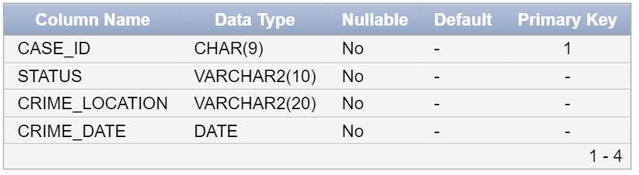

1. **Criminal**

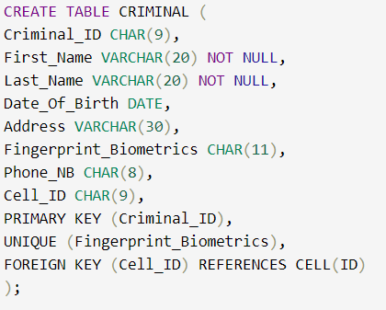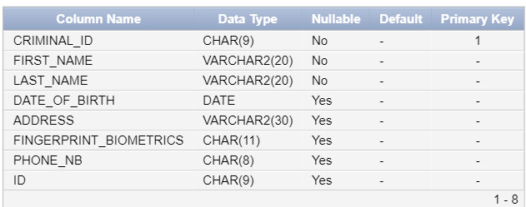

1. **Criminal_Record**

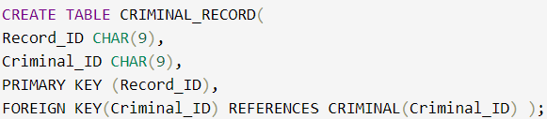

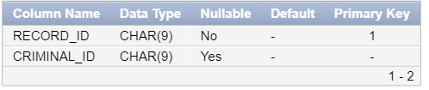

1. **Evidence**

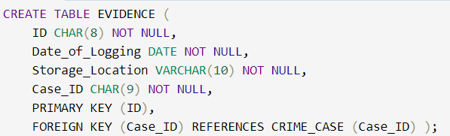

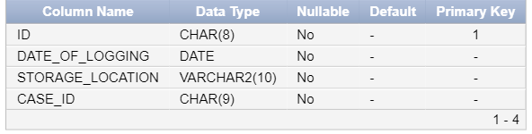

1. **Cell**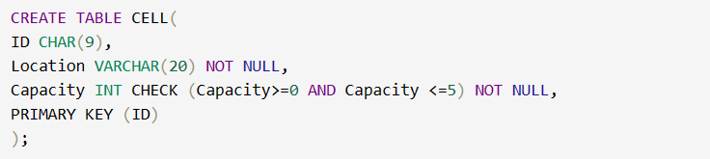

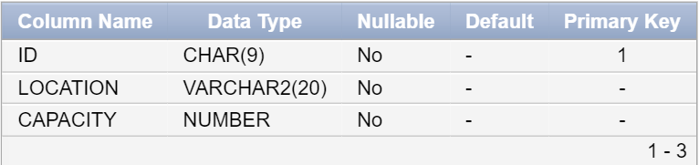

1. **Insurance**

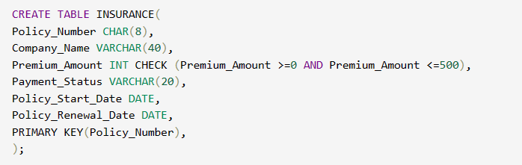

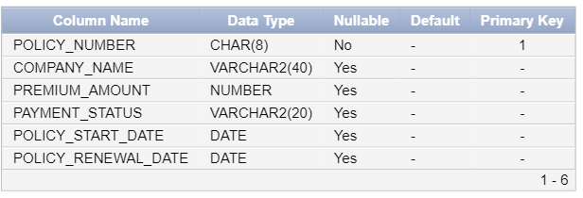

1. **Assigned_To**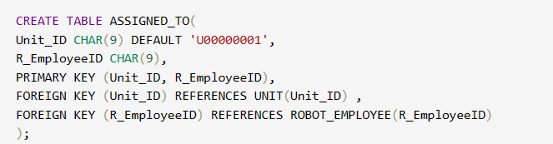

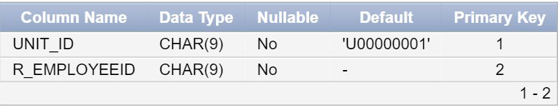

1. **Cam_Range**

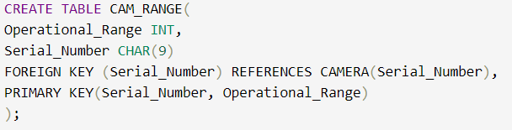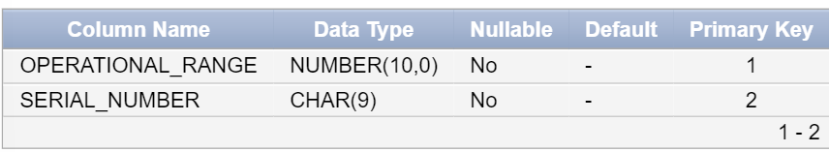

1. **Car_Color**

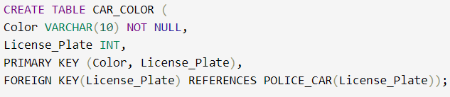

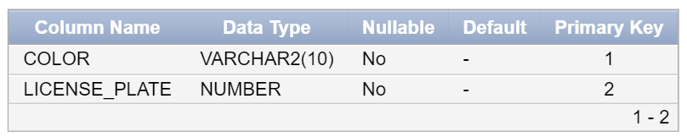

1. **Crime_Suspects**

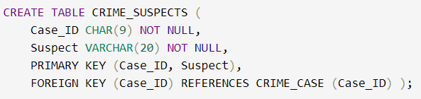

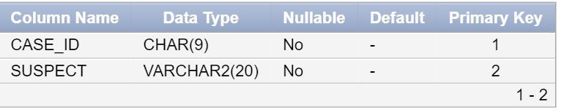

1. **Crime_Type**

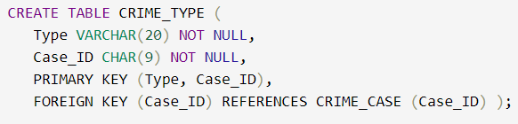

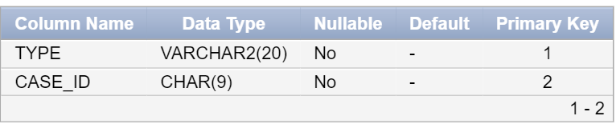

1. **Crime_Victims**

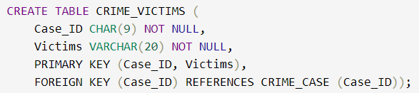

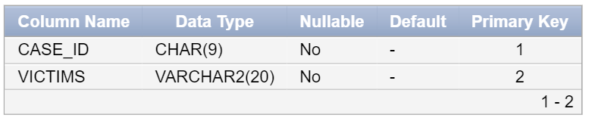

1. **Criminal_Has**

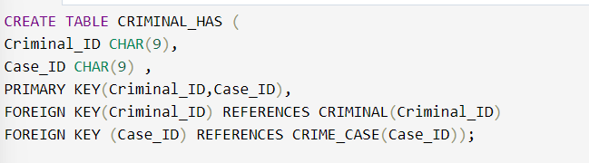

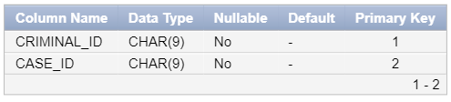

1. **Criminal_History_Record**

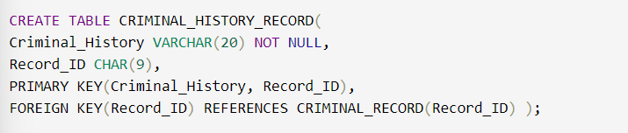

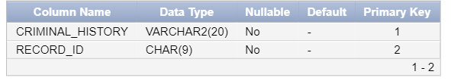

1. **Dog_Vaccination**

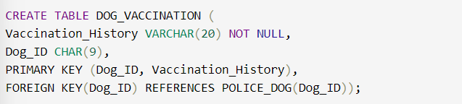

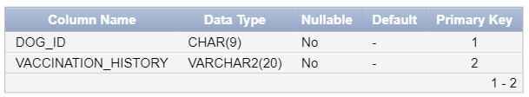

1. **Drives**

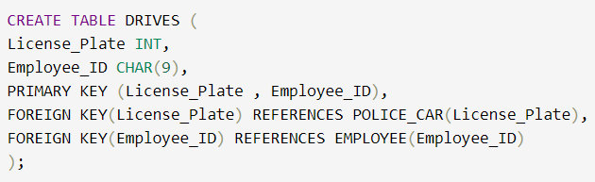

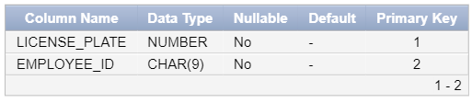

1. **Evidence_Type**

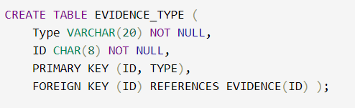

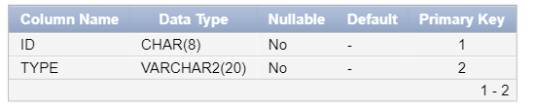

1. **Guards**

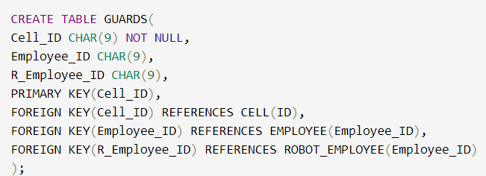

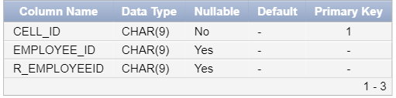

1. **Insurance_Cam**

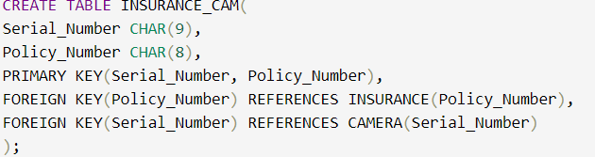

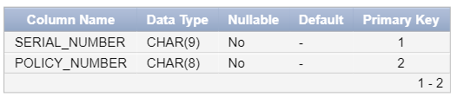

1. **Insurance_Car**

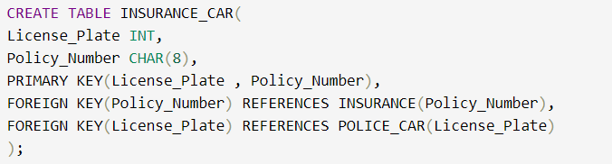

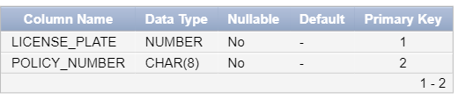

1. **Insurance_Dog**

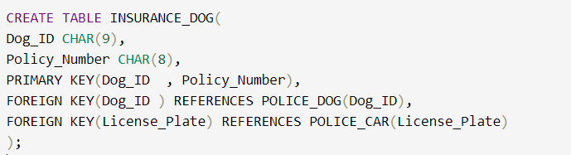

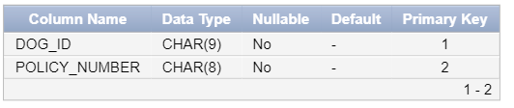

1. **Insurance_Employee**

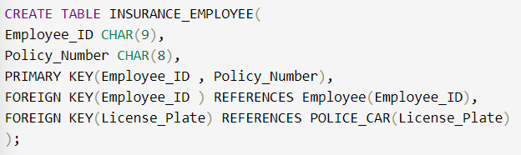

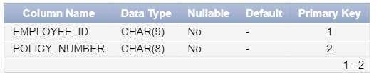

1. **Insurance_R_Employee**

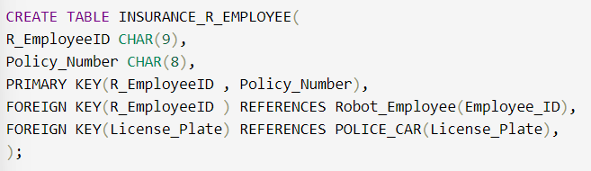

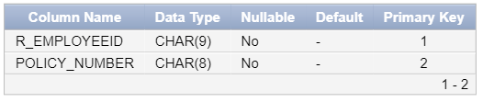

1. **Investigates**

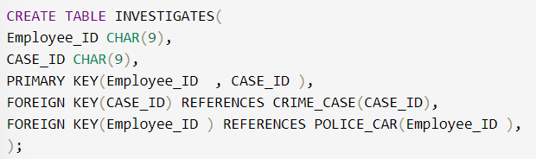

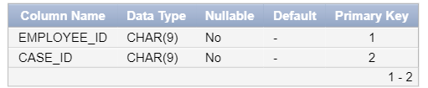

1. **Participates_In**

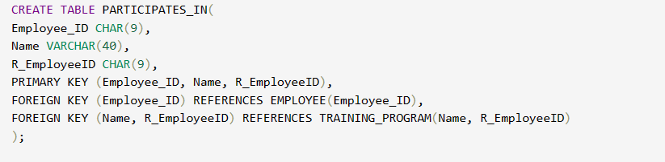

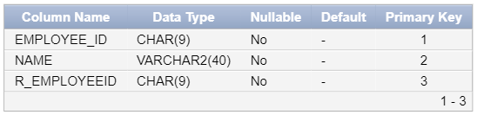

1. **Police_Car_Surveillence**

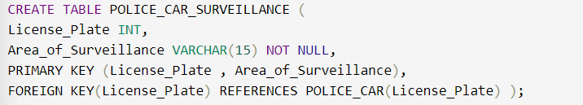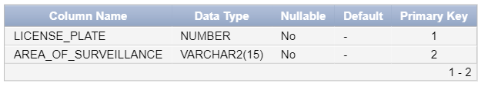

1. **Record_Of_Arrest**

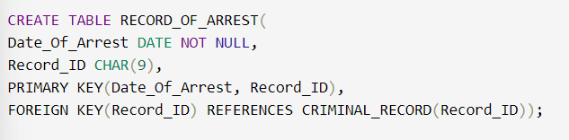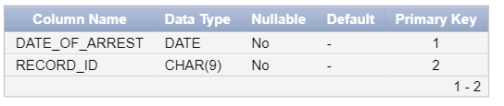

1. **Unit_Task**

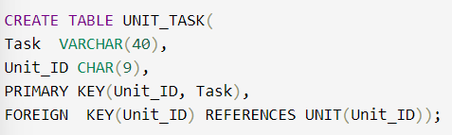

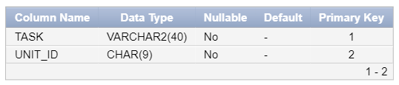

# Inserting the Data

The insertion of all data is similar. We chose to represent this one to show the syntax of insertion for data of type ‘Date’. Otherwise, there is no major change or necessity to mention other inserts as this one encapsulates the majority of insertions.

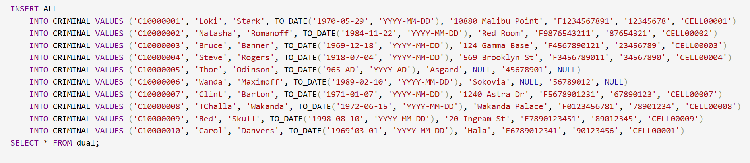

# Populating the Tables

## Employee

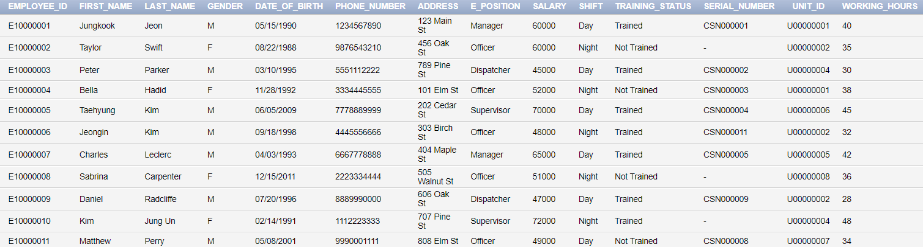

***-Kim Jung Un, North Korea’s Supreme Leader, “Working here has been the best experience of my life, and I’ve got nukes at my disposal!!”***

***-Charles Leclerc, F1 Ferrari Driver, “Zooming to catch these criminals is so much fun!!”***

***-Daniel Radcliffe, Harry Potter, “Working at such a station is quite magical, the janitor reminds me of Hagrid too!!”***

***-Andrew Garfield, Spiderman, “They did not let me wear my suit to work, anti Iron Man propaganda they said…”***

***-Taylor Swift, Singer, “Cause I knew these suspects were trouble when I caught them, so shame on them for harming the poor victims”***

## Robot_Employee

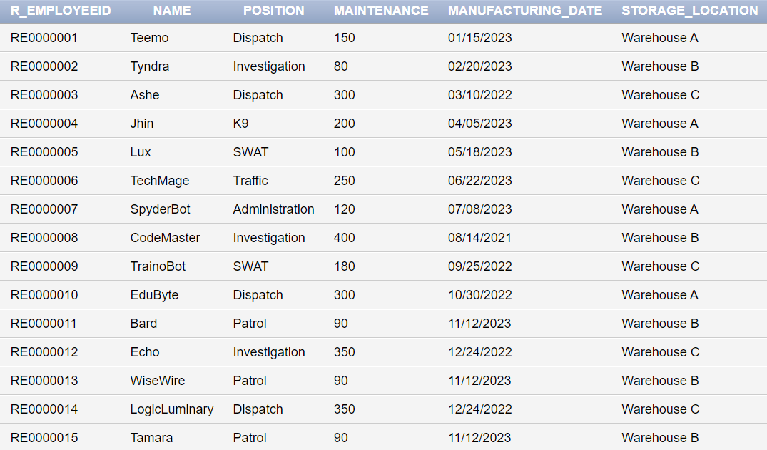

## Unit

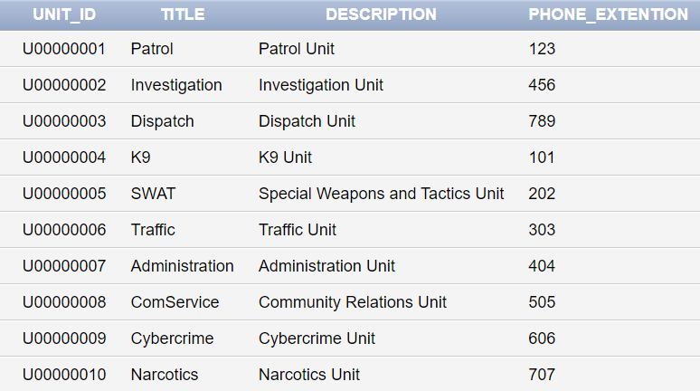

## Training_Program

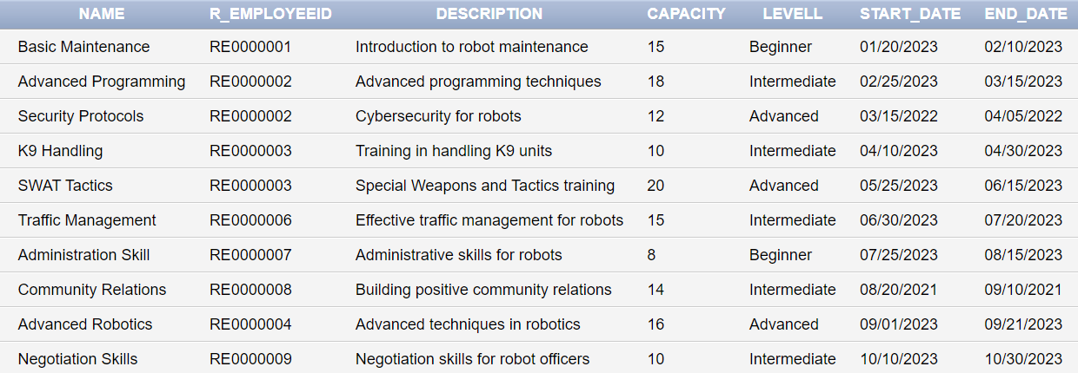

## Police_Camera

## Weaponry

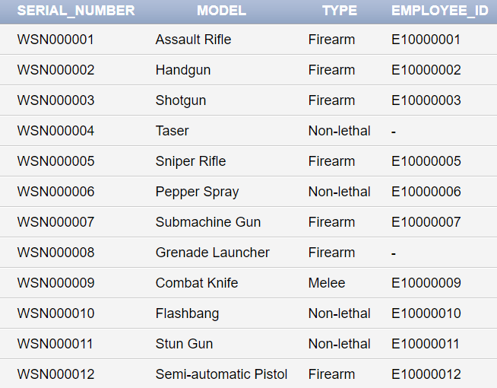

## Police_Car

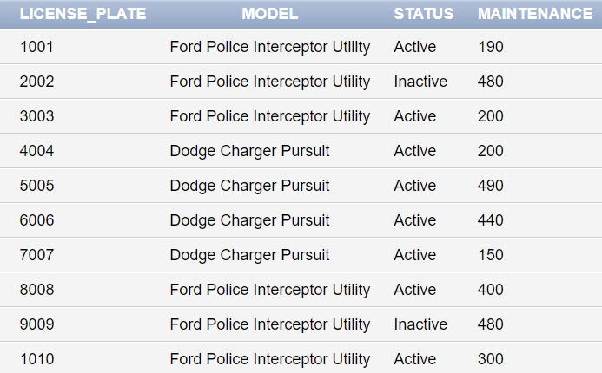

## Police_Dog

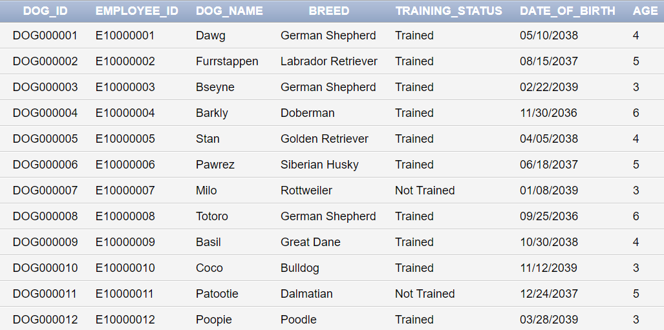

***StarkSafe takes pride in the names of its highly esteemed dogs. If they sound drunk to you it's because we usually come up with them on post “Closed Case” drink sessions,***

## Insurance

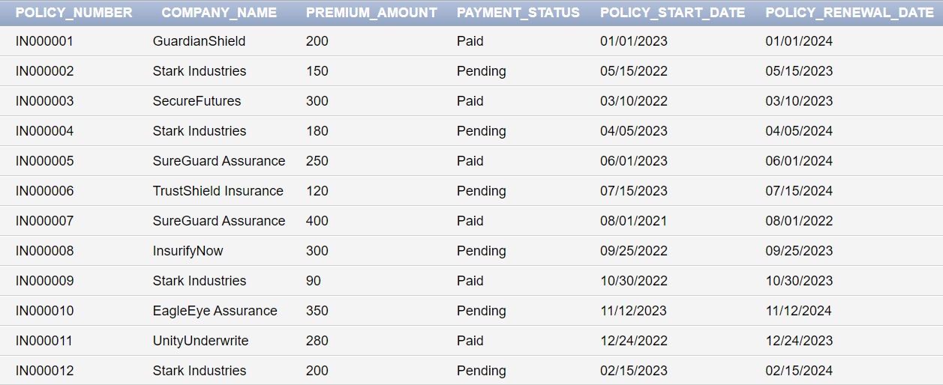

## Criminal

## Crime_Case

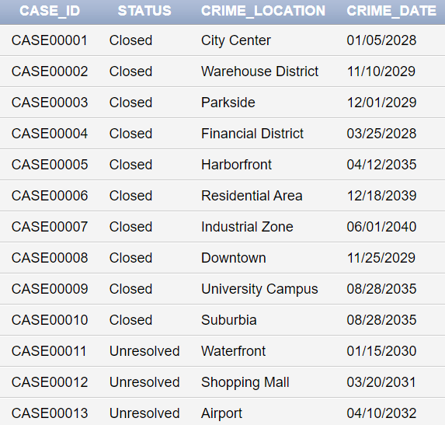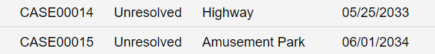

## Criminal_Record

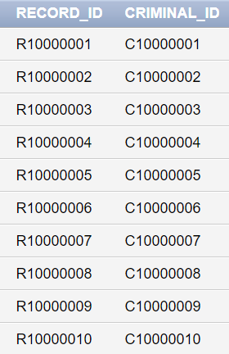

## Evidence

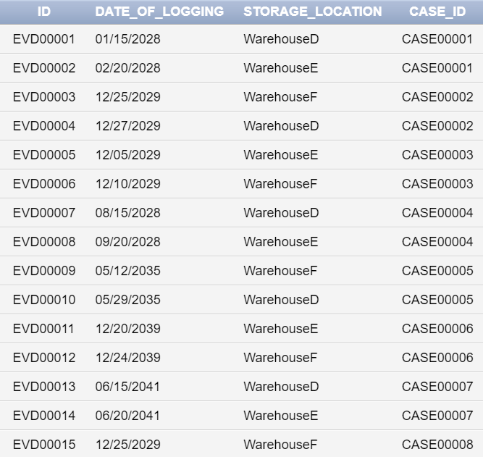

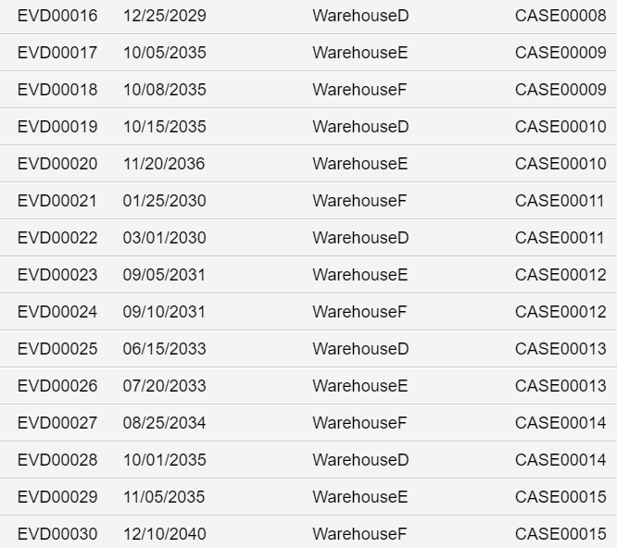

## Cell

## Assigned_To

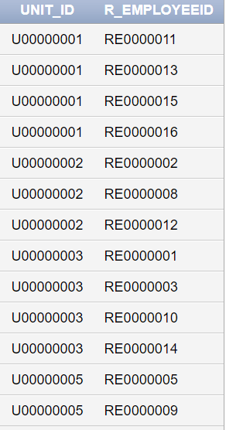

## Participates_In

## Drives

## Cam_Range

## Car_Color

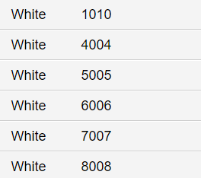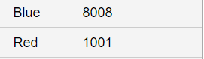

## Crime_Suspects

***Omar, Nour, Tala turned out to be innocent, they would never commit a crime***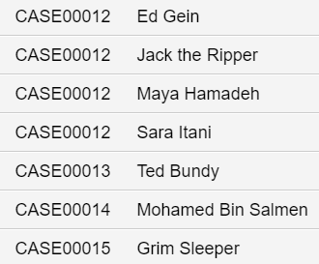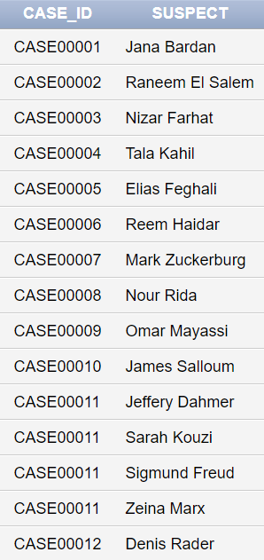

## Crime_Type

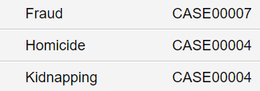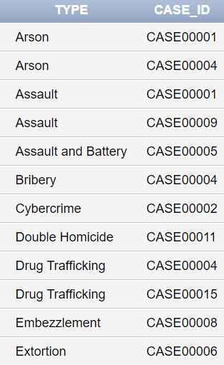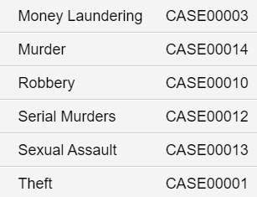

## Crime_Victims

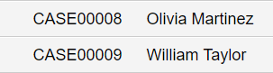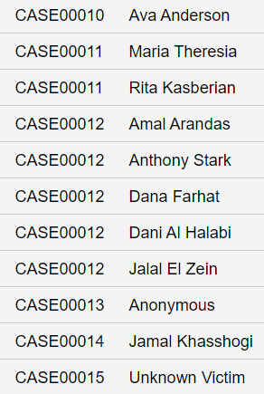

***Apple Inc. will be accepting donations after suffering from money laundering. Consider donating!***

## Criminal_Has

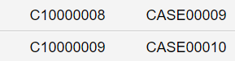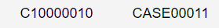

## Criminal_History_Record

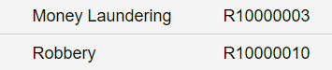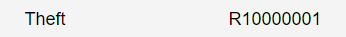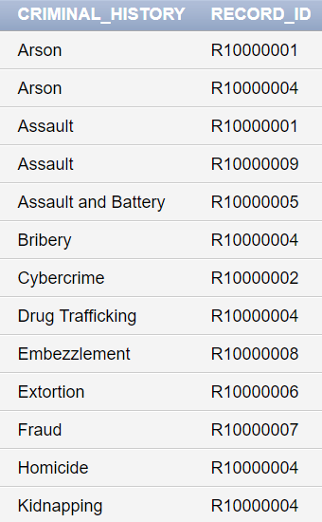

## Dog_Vaccination

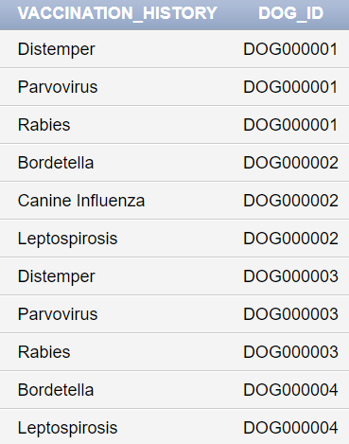

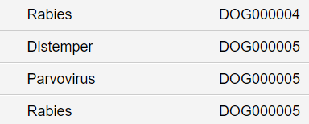

## Evidence_Type

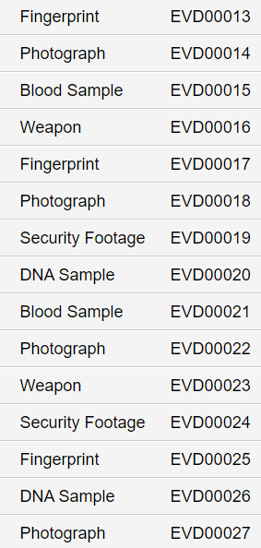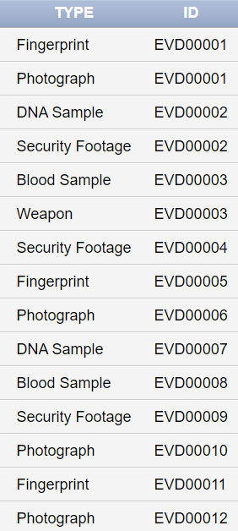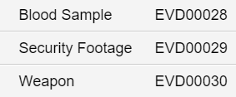

## Guards

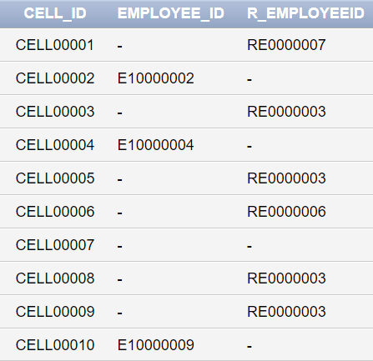

## Insurance_Cam

1. **Insurance_Car** 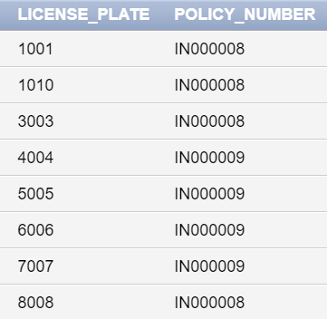

## 

## 

## Insurance_Dog

## 

## 

## Insurance_Employee

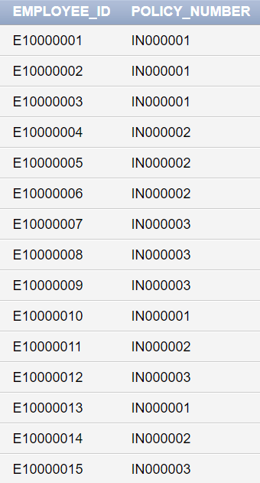

## Insurance_R_Employee

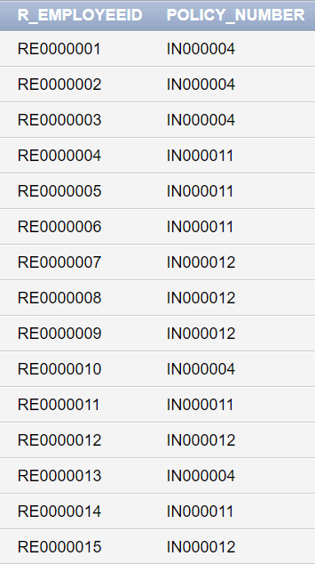

## Investigates

## 

## 

## 

## Police_Car_Surveillance

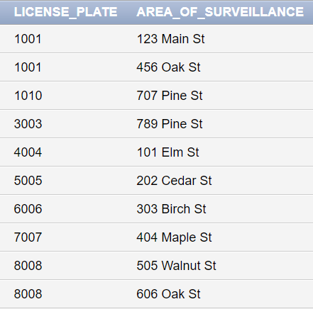

## Record_Of_Arrest

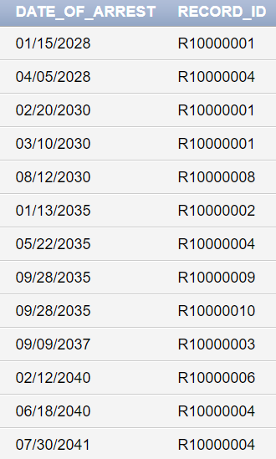

## Unit_Task

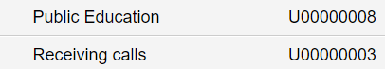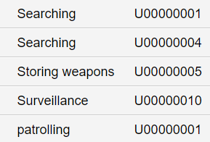

1. Queries

## 

## 1. Tony's Epiphany. Or is it?

In a world constantly evolving and constantly renewing their look on life, StarSafe has decided to study the gender statistics of its employees. Thus, our HR, Roy, was out on a mission to develop his idea : women were underrepresented in the police and protection agency. On Tony Stark’s annual visit to the company, our HR prepared a presentation for him that would walk him through the situation and out of his ego.

To do that, our HR heavily relied on the Database present.

1. As to not bring up gender underrepresentation directly, Roy began by presenting stats on salaries across the different units in the station, the maximum salary, and the employee earning it.

|  |
| --- |
| **CREATE VIEW** SALARY_UNIT **AS**  **SELECT** U.TITLE AS UNIT, COUNT(E.EMPLOYEE_ID) AS NUM_EMPLOYEES, SUM(E.SALARY) AS SALARY_COST, MAX(E.SALARY) AS MAX, MAX(E.FIRST_NAME) AS EMPLOYEE_WITH_MAX_SALARY  **FROM** UNIT U  **JOIN** EMPLOYEE E **ON** U.UNIT_ID=E.UNIT_ID  **WHERE** (E.SALARY, E.EMPLOYEE_ID) **IN** (  **SELECT** MAX(SALARY), EMPLOYEE_ID  **FROM** EMPLOYEE E2  **WHERE** E2.UNIT_ID = U.UNIT_ID  **GROUP BY** EMPLOYEE_ID  )  **GROUP BY** U.TITLE; |

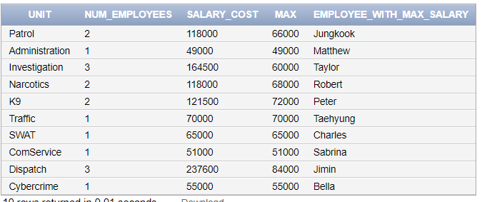

1. Then, Roy very clearly displayed the Max Salary employee and their gender.

|  |
| --- |
| **SELECT** SU.EMPLOYEE_WITH_MAX_SALARY, E.GENDER  **FROM** SALARY_UNIT SU, EMPLOYEE E  **WHERE** SU.EMPLOYEE_WITH_MAX_SALARY=E.FIRST_NAME; |

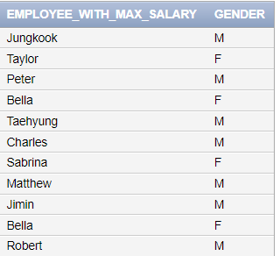

1. Not only that but Roy set out to show the difference in numbers between female and male managers across all units.

|  |
| --- |
| **//Females**  **SELECT** E.FIRST_NAME, E.GENDER  **FROM** EMPLOYEE E  **WHERE** E.GENDER = 'F' *AND* E.E_POSITION='Manager';  **//Males**  **SELECT** E.FIRST_NAME, E.GENDER  **FROM** EMPLOYEE E  **WHERE** E.GENDER = 'M' *AND* E.E_POSITION='Manager'; |

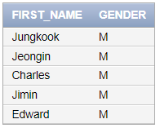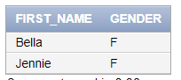

1. Although shocked, Tony’s shock did not transcend into any increase in salary like Roy had hoped. Instead, Tony set out on a mission to give emotional support to all the women that are underpaid. Unfortunately, ***we do not have queries for manipulation yet.***

## 2. A Bitter-Sweet Salary Increase

A surge of despair has swept over the community, leading to a string of heartbreaking suicides. The Dispatch and Investigation units at StarkSafe have been working tirelessly to uncover the root causes of these tragedies, fielding distress calls and meticulously examining every detail.

Stark, recognizing the emotional strain these cases have placed on the team, has expressed his deepest gratitude for their unwavering dedication and compassion. In a gesture of appreciation, he has announced a 20% salary increase for employees in these units, specifically targeting those earning between $50,000 and $70,000, acknowledging their exceptional contributions.

|  |
| --- |
| **UPDATE** EMPLOYEE  **SET** Salary = Salary * 1.2  **WHERE** Unit_ID **IN**  (  **SELECT** Unit_ID  **FROM** UNIT  **WHERE** Title **IN** ('Dispatch', 'Investigation')  )  *AND* (Salary BETWEEN 50000 AND 70000) |

***BEFORE***

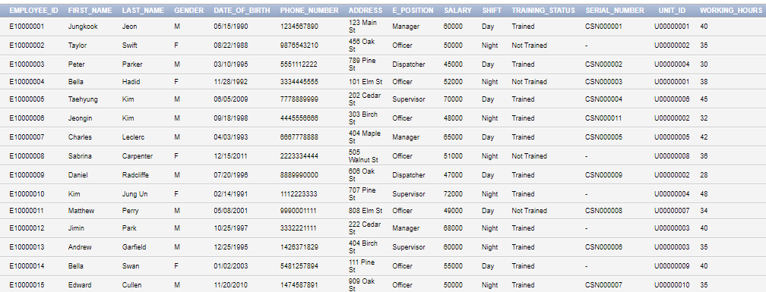

***AFTER***

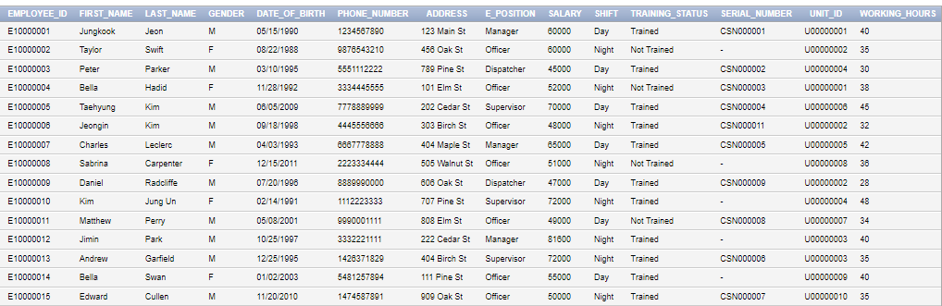

## 3. Architecture Students Tried to Give Gravity (And Us) an Assignment

The dispatch center received alarming news about a group of LAU architecture students planning to commit suicide by jumping off the Gezairi Building. This immediately sparked a frantic response from the station, as they scrambled to locate all employees with long-range cameras. These cameras would enable the dispatchers to precisely pinpoint the students' location while the university therapist engaged in dialogue with them and the on-campus security team prepared for a worst-case scenario. A new case was created in response to these events, and only those employees with prior case experience were assigned to handle the group suicide case.

1. Find all the employees that have a 100+M Operational Range:

|  |
| --- |
| **CREATE** VIEW NEW_CASE ***AS***  **SELECT** DISTINCT E.EMPLOYEE_ID, E.FIRST_NAME, E.LAST_NAME, CM.SERIAL_NUMBER  **FROM** CAM_RANGE CM, EMPLOYEE E  WHERE E.SERIAL_NUMBER=CM.SERIAL_NUMBER *AND* CM.OPERATIONAL_RANGE >=100; |

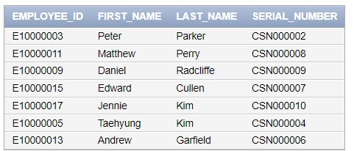

1. Create a new case ‘CASE00016’, adding it to the database and labeling it as a ‘Group Suicide’

|  |
| --- |
| **INSERT** ALL  **INTO** CRIME_CASE **VALUES** ('CASE00016', 'New', 'Gezairi Bloc A',  **TO_DATE**('2042-06-15', 'YYYY-MM-DD'))  SELECT * FROM dual; |

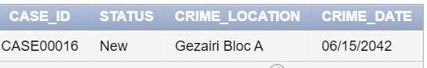

AND

|  |
| --- |
| **INSERT** ALL INTO CRIME_TYPE VALUES('Group Suicide', 'CASE00016')  **SELECT** * FROM dual; |

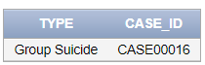

1. Now, choosing those that are currently assigned to a case, we will reassign them to the more pressing case of the group suicide as such:

|  |
| --- |
| **UPDATE** INVESTIGATES INV  **SET** INV.CASE_ID = 'CASE00016'  **WHERE** INV.EMPLOYEE_ID ***IN*** (**SELECT** NC.EMPLOYEE_ID **FROM** NEW_CASE NC); |

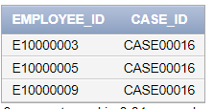

## 4. Robbing the Badge HQ? Rookie move.

There's been an attempted robbery of evidence in one of our warehouses! First, let's identify the cases whose evidence is stored in 'Warehouse F'.Once we know that, we can start to figure out what type of evidence it is.

Is it DNA evidence? Or maybe fingerprints? Or maybe it's something more dangerous, like weapons or drugs? Once we know what we're dealing with, we can start to move it to a temporary location that's safe from prying eyes.

This is going to be a tough job, but we're up to the challenge! Together, we can keep our evidence safe and bring the criminals to justice!

1. Identifying the cases and the type of evidence involved:

|  |
| --- |
| **SELECT** CS.Case_ID, ET.Type AS EVIDENCE  **FROM** EVIDENCE EV, EVIDENCE_TYPE ET, CRIME_CASE CS  **WHERE** EV.Storage_location = 'WarehouseF' *AND* EV.ID = ET.ID *AND* EV.CASE_ID=CS.CASE_ID  **ORDER** BY CASE_ID; |

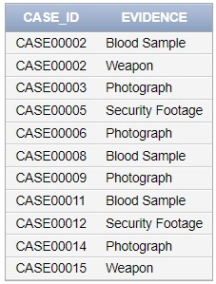

1. Updating their location to somewhere more secure and secret and then checking the current status of all our logged evidence.

|  |
| --- |
| **UPDATE** EVIDENCE E  **SET** E.STORAGE_LOCATION='TEMPORARY'  **WHERE** E.Storage_location = 'WarehouseF'; |

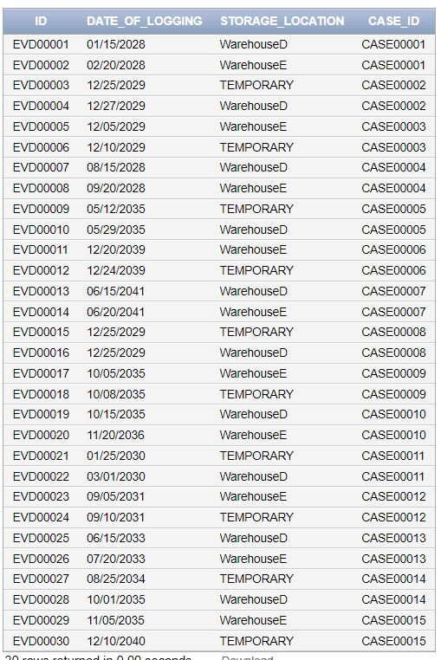

## 6. StarkSafe's Canine Check for Rabies

On a quiet gloomy day in Stark Town, a sinister shadow cast its veil as a mysterious outbreak of rabies emerged, spreading like wildfire through the unsuspecting community. The once-tranquil streets became filled with echoes of rabid menace as panic ensnared the community. StarkSafe feared for its four-legged officers to contract the disease, and so we wanted to make sure that our police dogs are vaccinated for rabies. For that, we want to check which of our dogs are not vaccinated for rabies. Those who aren't must receive the vaccine immediately. In order to prepare for future outbreaks, StarkSafe decided to also check the number of vaccinated police dogs against the common diseases in the area.

1. Checking which of our dogs are not vaccinated for rabies.

|  |
| --- |
| **SELECT** Dog_ID, Dog_Name  **FROM** POLICE_DOG  **WHERE** Dog_ID **NOT IN** (  **SELECT** Dog_ID  **FROM** DOG_VACCINATION  **WHERE** Vaccination_history= 'Rabies'  ) **ORDER BY** DOG_ID ; |

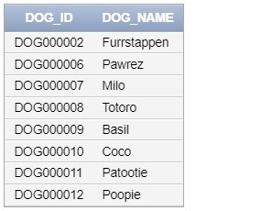

2. Vaccinating the non-immune dogs.

|  |
| --- |
| **INSERT INTO** DOG_VACCINATION (Vaccination_History, Dog_ID)  **SELECT** 'Rabies', Dog_ID  **FROM** POLICE_DOG  **WHERE** Dog_ID **NOT IN** (  **SELECT** Dog_ID  **FROM** DOG_VACCINATION  **WHERE** Vaccination_History = 'Rabies'  ); |

***BEFORE:***





***AFTER:***

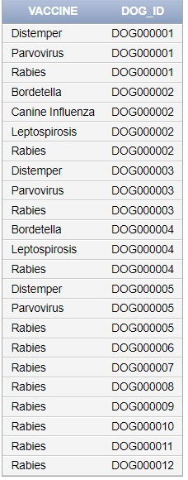

3. Checking the number of vaccinated dogs against a certain disease.

|  |
| --- |
| **SELECT** Vaccination_History **AS** VACCINE, **COUNT**(DISTINCT Dog_ID) **AS** NUMBEROF_DOGS_VACCINATED  **FROM** DOG_VACCINATION  **GROUP BY** Vaccination_History |

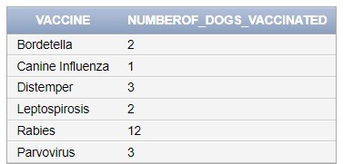

## 6. Unveiling the 'T' Factor in StarkSafe's Intermediate Training Programs

Amidst the bustling activity of StarkSafe Police Station, where the symphony of barks and the clatter of paws complemented the dedicated officers, an unexpected decree was about to unsettle the otherwise routine operations. Tony Stark, the station's flamboyant and somewhat egotistical proprietor, unveiled a momentous announcement. With a flourish, he declared, "Ladies and gentlemen, prepare to rejoice! I've decided to bestow upon all employees who participate in the intermediate-level training program a generous raise!" The news ignited a wildfire of excitement, and the atmosphere crackled with anticipation. Officers exchanged jubilant glances, their minds conjuring up images of upgraded coffee machines and extra treats for the K-9 unit. However, their joy was abruptly cut short.

In an unexpected turn of events, Tony, seized by a whim, decided to introduce a peculiar condition to the reward distribution. As the unsuspecting employees gathered for the announcement, Tony, sporting a self-satisfied grin, proclaimed, "Here's the twist, my dear colleagues. You'll only receive the raise if you chose a robot trainer whose first name starts with a 'T,' just like yours truly."

And so, we need a query to retrieve the first and last names of employees participating in an “Intermediate” level training program, instructed by a robot employee whose name starts with a ‘T’.

1. Selecting the fortunate employees

|  |
| --- |
| **SELECT** E.First_Name, E.Last_Name, R.Name **AS** Robot_Name, T.Name **AS** Training_Name  **FROM** EMPLOYEE E  **JOIN** PARTICIPATES_IN P ON E.Employee_ID = P.Employee_ID  **JOIN** TRAINING_PROGRAM T **ON** P.R_EmployeeID = T.R_EmployeeID  **JOIN** ROBOT_EMPLOYEE R **ON** T.R_EmployeeID = R.R_EmployeeID  **WHERE** T.R_EmployeeID **IN** (  **SELECT** R.R_EmployeeID  **FROM** ROBOT_EMPLOYEE R  **WHERE** R.Name **LIKE** 'T%'); |

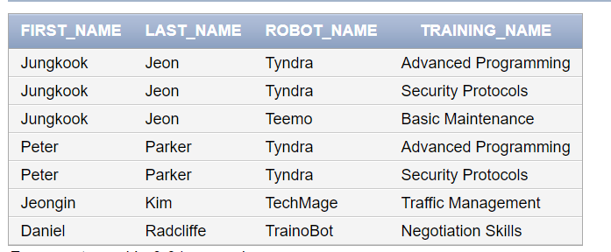

2) Updating the salaries

|  |
| --- |
| **UPDATE** EMPLOYEE  **SET** SALARY = SALARY * 1.1  **WHERE** FIRST_NAME **IN** (  **SELECT** **DISTINCT** E.First_Name  **FROM** EMPLOYEE E  **JOIN** PARTICIPATES_IN P **ON** E.Employee_ID = P.Employee_ID  **JOIN** TRAINING_PROGRAM T **ON** P.R_EmployeeID = T.R_EmployeeID  **JOIN** ROBOT_EMPLOYEE R **ON** T.R_EmployeeID = R.R_EmployeeID  **WHERE** T.R_EmployeeID **IN** (  **SELECT** R.R_EmployeeID  **FROM** ROBOT_EMPLOYEE R  **WHERE** R.Name **LIKE** 'T%')  ); |

For simplification purposes, here is a demo on one employee, where his salary increased by 10%

BEFORE:

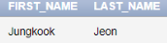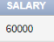

AFTER:

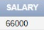

## 7. Ingenious Balance

Ofcourse, for a man like Tony, being rich comes with uttermost effort, and not the physical type of effort. Intelligence is needed in business, and that is what Tony Stark had. As Tony delved into financial reports, a frown crept over his face. The insurance costs, like the city's skyline, were reaching new heights. Owing favors to numerous insurers, Tony saw this not as a setback but an opportunity for innovation. Since everything at StarkSafe is alive through High-Level Vibranium Technology, it is only normal for insurance costs to be sky-high. Tony wanted to acquire the set of companies his police station owes insurance money to, and the amount that is owed.

|  |
| --- |
| **SELECT** INS.COMPANY_NAME, **SUM**(INS.PREMIUM_AMOUNT) **AS** OWED_AMOUNT  **FROM** INSURANCE INS  **WHERE** INS.PAYMENT_STATUS= 'Pending'  **GROUP BY** INS.COMPANY_NAME; |

## 8. The Ballet of the Trigger-Happy Toe

In StarkSafe’s early days when it was first founded, decisions were not as strategic as they are now. Tony still remembers the first time he led a team of officers into battle against some armed criminals. Because it was hard for him to manage his team without a DBMS, he sent out an untrained employee on a difficult quest. That employee eventually ended up accidentally shooting himself in the foot. Years later, the incident served as a valuable lesson for StarkSafe. With the implementation of an advanced DBMS, decision-making became more strategic, ensuring that only trained and seasoned officers were entrusted with critical missions involving weaponry. Tony was preparing to launch a counterattack on a criminal heist that was about to take place at the bank. For that, he needed to form a team of trained officers who know their way with a firearm. Since he knew that the number of criminals to be convicted is huge, he also wanted to make sure of the available spots of each cell at the police station.

1. Selecting officers who are well-trained, equipped with a firearm, and drive a police car.

|  |
| --- |
| **SELECT**  EMPLOYEE.Employee_ID,  EMPLOYEE.First_Name,  EMPLOYEE.Last_Name  **FROM**  EMPLOYEE  **JOIN**  WEAPONRY **ON** EMPLOYEE.Employee_ID = WEAPONRY.Employee_ID  **JOIN**  DRIVES **ON** EMPLOYEE.Employee_ID = DRIVES.Employee_ID  **WHERE**  EMPLOYEE.Training_Status = 'Trained'  *AND* WEAPONRY.Type = 'Firearm'  **ORDER BY**  EMPLOYEE.Employee_ID; |

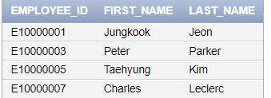

1. Finding out the current available spots in each cell

|  |
| --- |
| **SELECT**  CELL.ID **AS** Cell_ID,  CELL.Capacity - COUNT(CRIMINAL.Criminal_ID) **AS** Available_Spots  **FROM**  CELL  LEFT JOIN  CRIMINAL **ON** CELL.ID = CRIMINAL.ID  **GROUP BY**  CELL.ID, CELL.Capacity  **ORDER BY**  CELL.ID; |

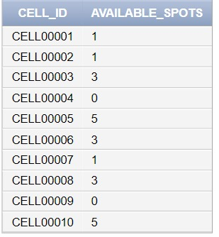

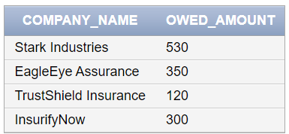

## 9. The Loss of Jungkook Jean

In an emotionally stirring twist of fate, our brave manager, Jungkook Jean, found himself entangled in an unfortunate incident during his noble duty, colliding with an enigmatic car driven by a mysterious individual. Both he and the unidentified driver were part of a regrettable car crash. Today, the remarkable Tony Stark graced our station with his presence, seeking more details about our cherished Patrol Unit Manager, Sr. Jean.

With the utmost consideration for Jean's family, we willingly shared his ID, date of birth, and address with Mr. Stark. In his characteristically humble manner, Stark expressed a sincere wish to personally inform Jean's family about this tragic incident. Additionally, we provided information about the insurance company and policy number, ensuring that necessary procedures for life insurance could be expeditiously arranged.

Amid these poignant moments, Stark conveyed his intention to contact the insurance company regarding the damaged cars. He kindly requested specific details about Jean's vehicle - including the license plate, model, and insurance policy number.

Finally, with somber hearts, it was time to bid Jean farewell in the database. Embracing the spirit of moving forward, the accomplished officer, Bella Hadid, was slated for promotion to the role of the new Patrol Unit Manager. Our station, a close-knit family of dedicated officers, continued to rally around one another through thick and thin, finding strength in unity and promoting love and compassion.

1. Jean’s ID, date of birth, address, and the insurance company that Jean was under alongside the policy number. We will create this as a view for easier access in later stages.

|  |
| --- |
| **CREATE VIEW** DEATH POLICY **AS**  **SELECT** E.EMPLOYEE_ID, E.DATE_OF_BIRTH, E.ADDRESS, U.TITLE, INSE.Policy_Number, INS.COMPANY_NAME  **FROM** EMPLOYEE E, UNIT U, INSURANCE INS, INSURANCE_EMPLOYEE INSE  **WHERE** E.FIRST_NAME='Jungkook' *AND*  U.UNIT_ID=E.UNIT_ID *AND*  INSE.EMPLOYEE_ID=E.EMPLOYEE_ID *AND* INSE.POLICY_NUMBER=INS.POLICY_NUMBER  ; |

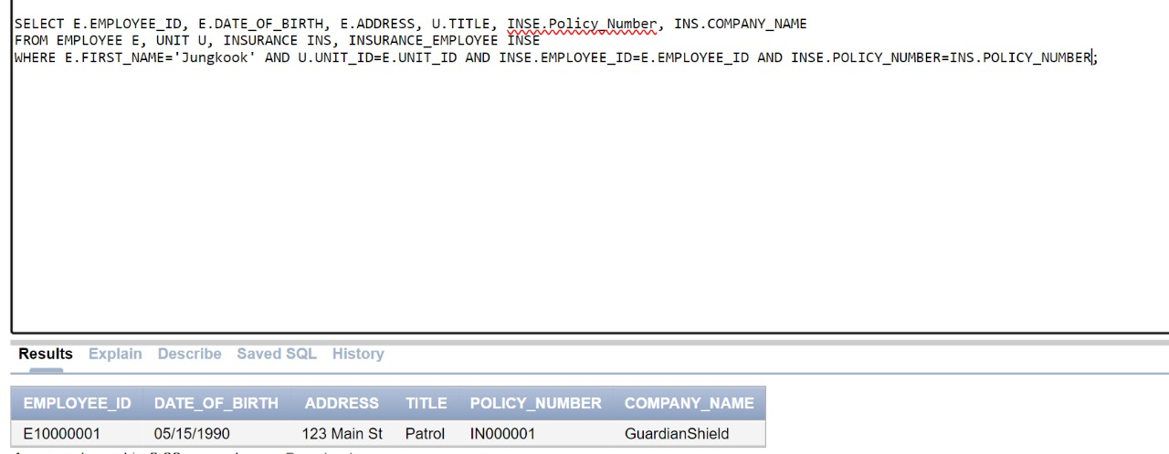

1. The license plate, model, and insurance policy number of the car Jean used to drive.

|  |
| --- |
| **SELECT** D.License_Plate, CR.MODEL, INSC.POLICY_NUMBER  **FROM** DRIVES D, POLICE_CAR CR, DEATH_POLICY DTH, INSURANCE_CAR INSC  **WHERE** DTH.EMPLOYEE_ID=D.EMPLOYEE_ID *AND* D.LICENSE_PLATE=CR.LICENSE_PLATE *AND* INSC.LICENSE_PLATE=D.LICENSE_PLATE; |

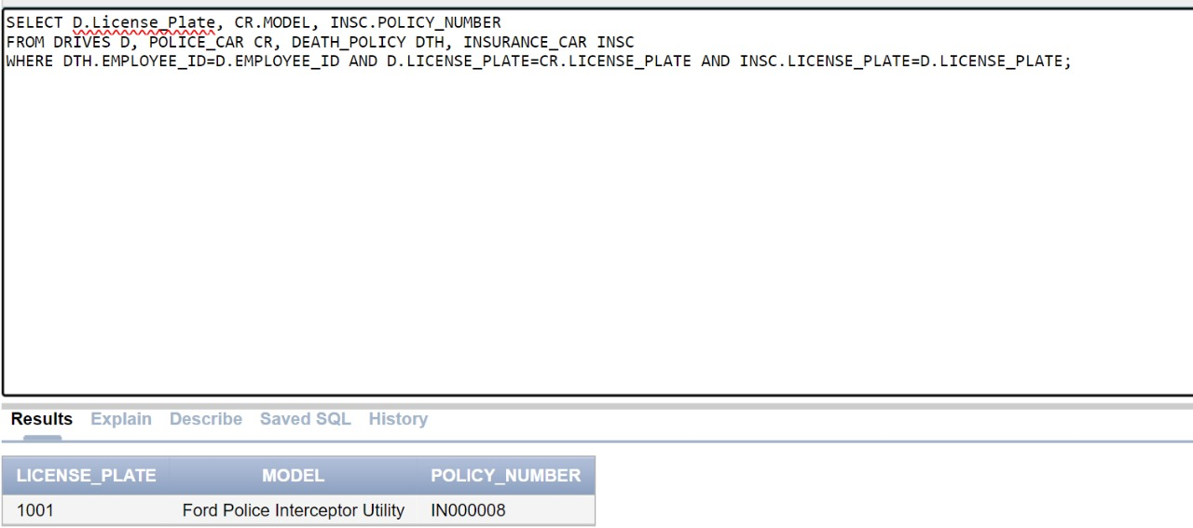

1. Although heartbreaking to write, this is how we removed Jean from our database:

|  |
| --- |
| **DELETE FROM** EMPLOYEE  **WHERE** FIRST_NAME=’Jungkook’; |

1. Now, we must move forward by promoting our dearest Bella:

|  |
| --- |
| **UPDATE** EMPLOYEE E  **SET** E.E_POSITION = 'Manager'  **WHERE** E.E_POSITION = 'Officer'  *AND* EXISTS (  **SELECT** 1  **FROM** EMPLOYEE M, UNIT U  **WHERE** M.E_POSITION = 'Manager'  *AND* E.UNIT_ID = M.UNIT_ID  *AND* U.UNIT_ID = E.UNIT_ID  ); |

*BEFORE*

**

*AFTER*

**

## 10. Inquisitive pursuits

In a city where shadows whisper secrets, crime is always lurking, whether in broad daylight or in the midst of the coal black night. Fortunately for our community, StarkSafe never sleeps. The tenacious detectives of StarkSafe possess an uncanny ability to unravel the threads of any crime, transforming complex puzzles into clear narratives of justice. Although some cases may go cold or unresolved, our database keeps track of it so that it is a continuous task for all our investigators to work on. Since investigation is a difficult task that yields good outcomes, Tony Stark decided to evaluate each employee based on the number of cases investigated. Tony would also like a list of all the unresolved cases.

1)Finding the number of cases each employee has investigated

|  |
| --- |
| **SELECT** e.Employee_ID, e.First_Name, e.Last_Name, COUNT(DISTINCT c.Case_ID) **AS** Cases_Investigated  **FROM** EMPLOYEE e  **LEFT JOIN** INVESTIGATES i **ON** e.Employee_ID = i.Employee_ID  **LEFT JOIN** CRIME_CASE c **ON** i.Case_ID = c.Case_ID  **GROUP BY** e.Employee_ID, e.First_Name, e.Last_Name; |

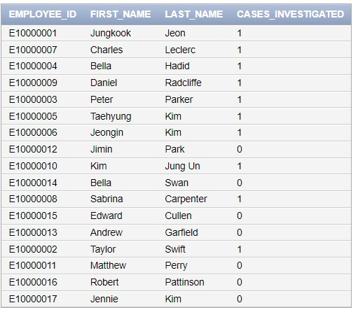

2)Finding unsolved Serial Murders crimes.

|  |
| --- |
| **SELECT** c.Case_ID, c.Status, c.Crime_Location, c.Crime_Date  **FROM** CRIME_CASE c  **JOIN** CRIME_TYPE ct **ON** c.Case_ID = ct.Case_ID  **WHERE** c.Status = 'Unresolved' *AND* ct.Type = 'Serial Murders'; |

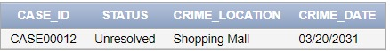

## 11. Justice Unveiled

The Department of Justice contacted StarkSafe and wanted to inquire about the victims of assault and battery assault to compensate them with benefits. So, in this query, we want to retrieve all these victims stating whether the case is closed or not. We also want to get the convicted criminals.

Title.

|  |
| --- |
| **SELECT** CV.VICTIMS VICTIM_NAME , CC.TYPE, C.FIRST_NAME Criminal_FirstName, C.LAST_NAME Criminal_LastName, CS.STATUS  **FROM** CRIMINAL C, CRIME_TYPE CC, CRIMINAL_HAS CH, CRIME_CASE CS, CRIME_VICTIMS CV  **WHERE** CC.TYPE LIKE 'Assault%' *AND* CC.CASE_ID=CH.CASE_ID *AND* CH.CRIMINAL_ID=C.CRIMINAL_ID *AND* CS.CASE_ID=CH.CASE_ID *AND* CV.CASE_ID=CH.CASE_ID; |

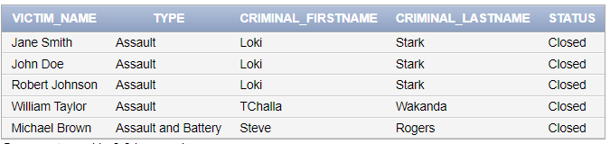

## 12. 'Paw-ty' Preps for Officer-Dog Day

Hoping to take our hardworking and beloved dogs on a trip, Tony has decided that it is only fair that we conduct an annual Officer-Dog Day. However, due to health restrictions, we cannot set free any dog that is not vaccinated and trained. For further clarity, the dog will be accompanied by his trainer. This the name of the dog, his trainers’ name will be ready to get started with Officer-Dog Day preps.

|  |
| --- |
| **SELECT** DISTINCT D.DOG_NAME, E.FIRST_NAME AS TRAINER_FIRSTNAME,  E.LAST_NAME AS TRAINER_LASTNAME  **FROM** POLICE_DOG D, EMPLOYEE E, DOG_VACCINATION DV  **WHERE** D.EMPLOYEE_ID=E.EMPLOYEE_ID AND D.TRAINING_STATUS= 'Trained' AND DV.DOG_ID=D.DOG_ID; |

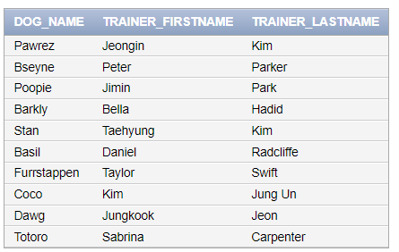

## 13. An Average Day at StarkSafe

At StarkSafe, an average day unfolds amidst a symphony of dedicated law enforcement professionals, each unit working tirelessly to ensure the city's safety. Tony Stark, the founder, injects a touch of friendly competition to fuel the spirit of the units. As the sun rises, the units commence their shifts, working to investigate crimes and uphold justice. Tony introduces an incentive program, sparking a healthy rivalry to see which unit can log the most working hours.

|  |
| --- |
| **SELECT**  UNIT.Unit_ID,  **ROUND**(**AVG**(EMPLOYEE.Working_Hours),2) **AS** Average_Working_Hours  **FROM**  UNIT  **JOIN**  EMPLOYEE **ON** UNIT.Unit_ID = EMPLOYEE.Unit_ID  **GROUP BY**  UNIT.Unit_ID  **HAVING**  **AVG**(EMPLOYEE.Working_Hours) > 20  **ORDER BY**  UNIT.Unit_ID; |

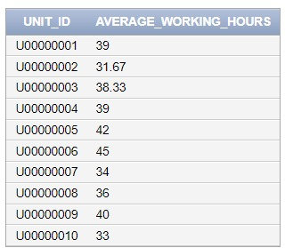

IV. Normalization

Normalization is an approach to organizing data in a relational database used to minimize redundancy and improve data integrity. It involves restructuring the database to eliminate duplicate data and ensure that each piece of data is stored only once.

Normalization adheres to a set of guidelines known as normal forms. In our database, we are going to normalize our database up to the Boyce­Codd Normal Form (BCNF), which is preceded by the 1st, 2nd, and 3rd Normal Form.

BCNF is considered the highest level of normalization that is commonly used in practice. Higher levels of normalization, such as 4NF and 5NF, exist, but they are rarely used because they are more complex and less efficient to maintain.

# Some Fundamental Concepts

* **Functional Dependencies:** These dependencies represent relationships between two attribute sets within a database. The values of the Y component in a tuple from relation R are determined by the values of the X component. This implies that Y is functionally dependent on X.
* **Prime Attribute:** An attribute that belongs to a primary key in relation R. A **non-prime** attribute is one that doesn't belong to any key.
* **Full Functional Dependency:** A functional dependency X →Y is considered a full functional dependency if removing any attribute A from X results in the dependency no longer holding.
* **Partial Dependency:** A functional dependency X →Y is classified as a partial functional dependency if removing any attribute A from X doesn't affect the dependency.
* **Transitive Dependency:** A functional dependency X →Y in relation schema R is considered a transitive dependency if there exists an attribute set Z in R that doesn't qualify as a candidate key or a subset of any key in R, and both X →Z and Z →Y hold.

# First Normal Form (1NF)

This form does not allow multivalued attributes, composite attributes, and their combinations to exist in a

relation.A relation adheres to 1NF if it satisfies the following conditions:

1. Only attribute values permitted are single atomic values.
2. Domain of an attribute must only include atomic values and the value of an attribute in a tuple

must be a single value from the domain of that attribute.

1. Disallows having a set of values as an attribute value for a single tuple.

# Second Normal Form (2NF)

A relation schema R is considered to be in Second Normal Form (2NF) if it adheres to the following conditions:

1. It conforms to the First Normal Form (1NF)
2. Every non-prime attribute in R is fully functionally dependent on every key of R
3. No non-prime attribute A in R is partially dependent on any key in R

# 

# Third Normal Form (3NF)

A relation schema R is in Third Normal Form (3NF) if it meets the following conditions:

1. It adheres to the Second Normal Form (2NF)
2. No non-prime attribute of R is transitively dependent on the primary key
3. In every non-trivial functional dependency X →Y, either X should be a super key or Y should be a prime attribute.

# 

# Boyce Codd Normal Form (BCNF)

The Boyce-Codd Normal Form (BCNF) is a more stringent form than the Third Normal Form (3NF). The BCNF differs from 3NF in only one aspect: 3NF allows the right-hand side of a functional dependency to be a prime attribute, while BCNF **strictly prohibits this.**

# Non-Normalized Schemas

## Employee

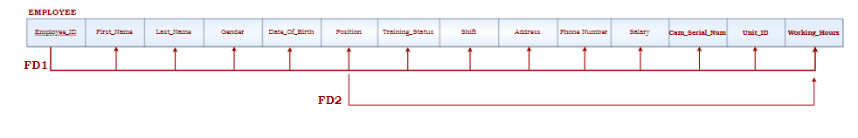

**A.** The **EMPLOYEE** relation schema satisfies all conditions of the **1NF** because it has neither multivalued attributes nor composite attributes. No nested relations are present as well. All attributes are single and atomic.

**B.** The **EMPLOYEE** relation schema satisfies all conditions of the **2NF** because every non-prime attribute is fully functionally dependent on the primary key “Employee_ID”.

**C.** The **EMPLOYEE** relation schema does not satisfy all conditions of the **3NF** because the functional dependency represented by “**Position → Working_Hours**” is an FD where neither *Position* is a superkey nor *Working_Hours* is a prime attribute. Thus, further decomposition is needed.

**As such:**

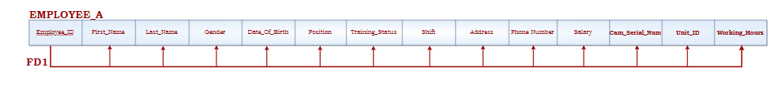 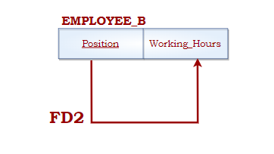

**D.** The **EMPLOYEE_A** and **EMPLOYEE_B** relation schemas satisfy all conditions of the **BCNF** because there exists no functional dependency **X → A** where X is not a super key.

## Unit

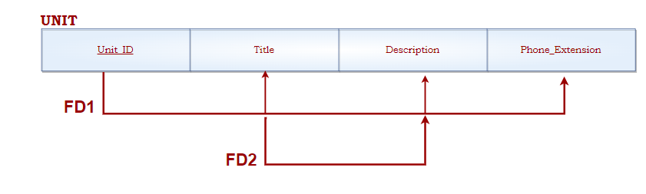

**A.** The **UNIT** relation schema satisfies all conditions of the **1NF** because it has neither multivalued attributes nor composite attributes. No nested relations are present as well. All attributes are single and atomic.

**B.** The **UNIT** relation schema satisfies all conditions of the **2NF** because every non-prime attribute is fully functionally dependent on the primary key “Unit_ID”.

**C.** The **UNIT** relation schema does not satisfy all conditions of the **3NF** because the functional dependency represented by “**Title →Description**” is an FD where neither *Title* is a superkey nor *Description* is a prime attribute. Thus, further decomposition is needed.

**As such:**

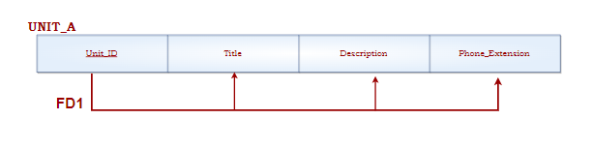

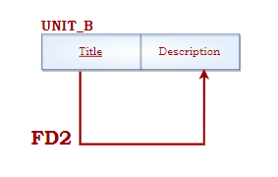

**D.** The **UNIT_A** and **UNIT_B** relation schemas satisfy all conditions of the **BCNF** because there exists no functional dependency **X → A** where X is not a super key.

## Training Program

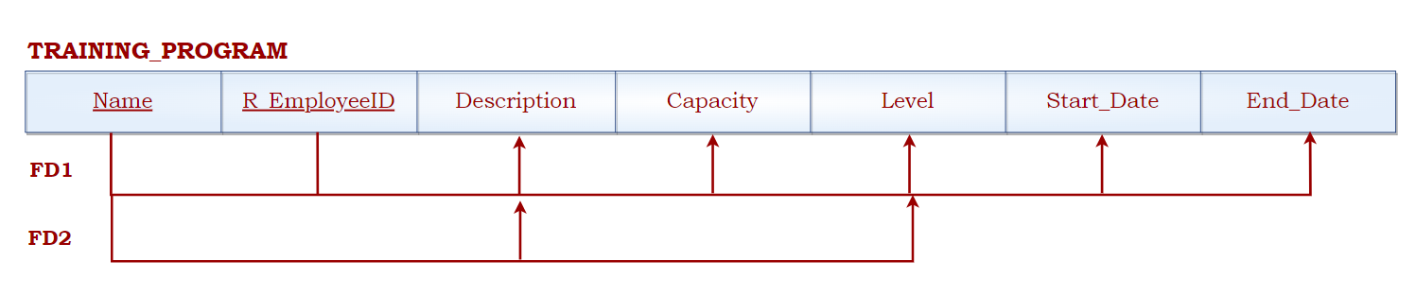

**A.** The **TRAINING_PROGRAM** relation schema satisfies all conditions of the **1NF** because it has neither multivalued attributes nor composite attributes. No nested relations are present as well. All attributes are single and atomic.

**B.** The **TRAINING_PROGRAM** relation schema does not satisfy all conditions of the **2NF** because the non-prime attributes *Description* and *Level* are partially functionally dependent on *Name.* It is partially dependent because the **TRAINING_PROGRAM** relation schema has {Name, R_EmployeeID} as its primary key. Thus further decomposition for FD2 is needed.

**As such:**

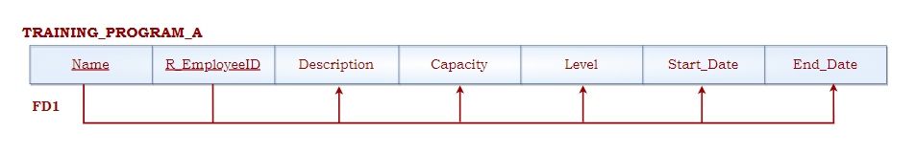

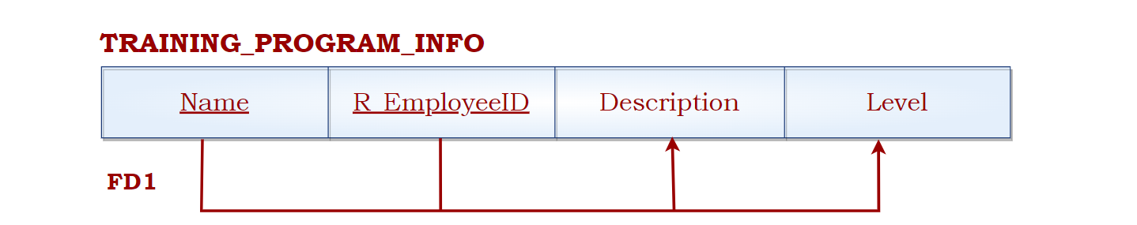

**C.** The **TRAINING_PROGRAM_INFO** and **TRAINING_PROGRAM_A** relation schemas satisfy all conditions of the **3NF** because they satisfy the **2NF** and there aren't any non-prime attributes that are transitively dependent on the primary key {Name, R_EmployeeID}.

**D.** The **TRAINING_PROGRAM_INFO** and **TRAINING_PROGRAM_A** relation schemas satisfy all conditions of the **BCNF** because there exists no functional dependency **X → A** where X is not a super key.

## Criminal

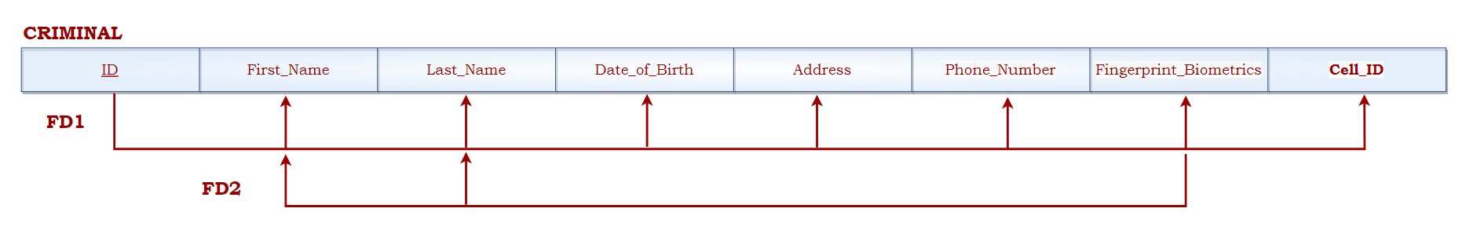

**A.** The **CRIMINAL** relation schema satisfies all conditions of the **1NF** because it has neither multivalued attributes nor composite attributes. No nested relations are present as well. All attributes are single and atomic.

**B.** The **CRIMINAL** relation schema satisfies all conditions of the **2NF** because every non-prime attribute is fully functionally dependent on the primary key “ID”.

**C.** The **CRIMINAL** relation schema does not satisfy all conditions of the **3NF** because the functional dependency represented by “**Fingerprint_Biometrics →{First_Name, Last_Name}**” is an FD where *Fingerprint_Biometrics* is not a superkey and neither *First_Name* nor *Last_Name* is a prime attribute. Thus, further decomposition is needed.

**As such:**

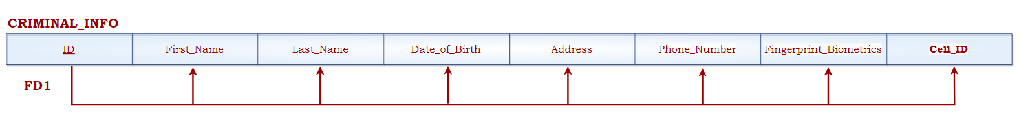

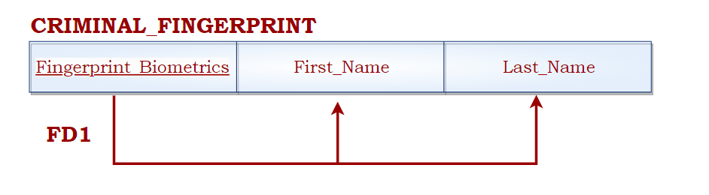

**D.** The **CRIMINAL_FINGERPRINT** and **CRIMINAL_INFO** relation schemas satisfy all conditions of the **BCNF** because there exists no functional dependency **X → A** where X is not a super key.

# Normalized Schemas

## Police Dog

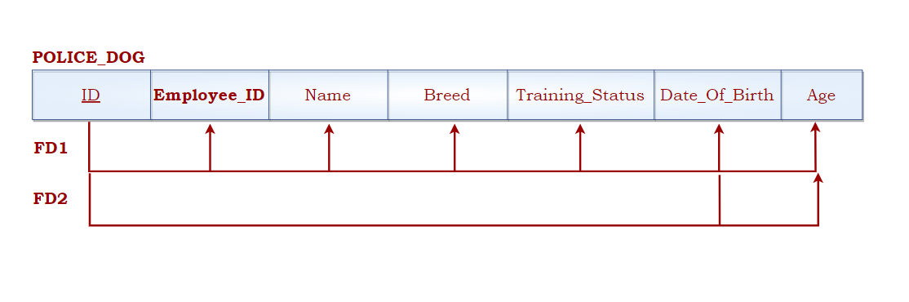

**A.** The **POLICE_DOG** relation schema satisfies all conditions of the **1NF** because it has neither multivalued attributes nor composite attributes. No nested relations are present as well. All attributes are single and atomic.

**B.** The **POLICE_DOG** relation schema satisfies all conditions of the **2NF** because every non-prime attribute is fully functionally dependent on the primary key “ID”.

**C.** The **POLICE_DOG** relation schema satisfies all conditions of the **3NF** because it satisfies the **2NF** and there aren't any non-prime attributes that are transitively dependent on the primary key “ID”.

**D.** The **POLICE_DOG** relation schema satisfies all conditions of the **BCNF** because there exists no functional dependency **X→A** where X is not a super key. FD2 satisfies **BCNF** as well since {ID, Date_Of_Birth} is a super key.

## Crime Case

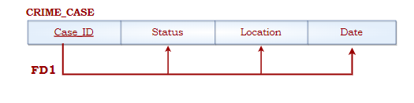

**A.** The **CRIME_CASE** relation schema satisfies all conditions of the **1NF** because it has neither multivalued attributes nor composite attributes. No nested relations are present as well. All attributes are single and atomic.

**B.** The **CRIME_CASE** relation schema satisfies all conditions of the **2NF** because every non-prime attribute is fully functionally dependent on the primary key “Case_ID”.

**C.** The **CRIME_CASE** relation schema satisfies all conditions of the **3NF** because it satisfies the **2NF** and there aren't any non-prime attributes that are transitively dependent on the primary key “Case_ID”.

**D.** The **CRIME_CASE** relation schema satisfies all conditions of the **BCNF** because there exists no functional dependency **X→A** where X is not a super key.

## Robot Employee

**A.** The **ROBOT_EMPLOYEE** relation schema satisfies all the conditions of **1NF** as it has no composite attributes, no multivalued ones, and no nested relations. These attributes are also single and atomic.

**B.** The **ROBOT_EMPLOYEE** relation schema satisfies all the conditions of **2NF** since all the non-prime attributes are functionally dependent on the primary key “Employee_ID”.

**C.** The **ROBOT_EMPLOYEE** relation schema satisfies the requirements of **3NF** as it is in line with 2NF as well as the fact that no transitive non-prime attributes are dependent on the primary key “Employee_ID”.

**D.** The **ROBOT_EMPLOYEE** relation schema satisfies the conditions of **BCNF** since no functional dependency **X→A** exists where X is not a super key.

## Insurance

**A.** The **INSURANCE** relation schema satisfies all the conditions of **1NF** as it has no composite attributes, no multivalued ones, and no nested relations. These attributes are also single and atomic.

**B.** The **INSURANCE** relation schema abides with all the conditions of **2NF** since all the non-prime attributes are functionally dependent on the primary key “Policy_Number”.

**C.** The **INSURANCE** relation schema satisfies the requirements of **3NF** as it is in line with **2NF** considering that no transitive non-prime attributes are dependent on the primary key “Policy_Number”.

**D.** The **INSURANCE** relation schema satisfies the conditions of **BCNF** since no functional dependency **X→A** exists where X is not a super key.

## Police Camera

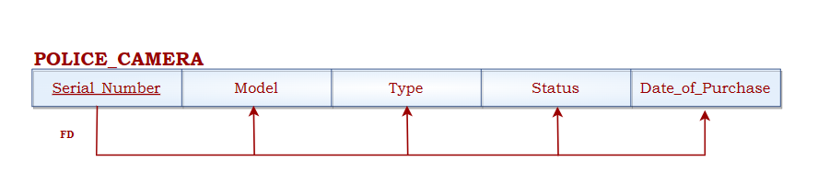

**A.** The **POLICE_CAMERA** relation schema satisfies all conditions of the **1NF** because it has neither multivalued attributes nor composite attributes. No nested relations are present as well. All attributes are single and atomic.

**B.** The **POLICE_CAMERA** relation schema satisfies all conditions of the **2NF** because every non-prime attribute is fully functionally dependent on the primary key “Serial_Number”.

**C.** The **POLICE_CAMERA** relation schema satisfies all conditions of the **3NF** because it satisfies the 2NF and there aren't any non-prime attributes that are transitively dependent on the primary key “Serial_Number”.

**D.** The **POLICE_CAMERA** relation schema satisfies all conditions of the **BCNF** because there exists no functional dependency **X→A** where X is not a super key.

## Weaponry

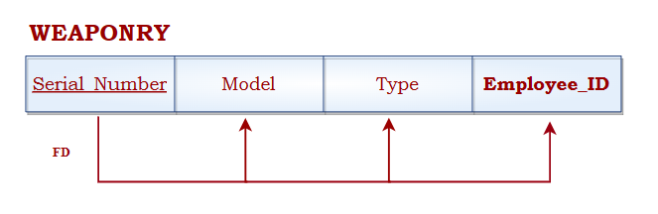

**A.** The **WEAPONRY** relation schema satisfies all conditions of the **1NF** because it has neither multivalued attributes nor composite attributes. No nested relations are present as well. All attributes are single and atomic.

**B.** The **WEAPONRY** relation schema satisfies all conditions of the **2NF** because every non-prime attribute is fully functionally dependent on the primary key “Serial_Number”.

**C.** The **WEAPONRY** relation schema satisfies all conditions of the **3NF** because it satisfies the **2NF** and there aren't any non-prime attributes that are transitively dependent on the primary key “Serial_Number”.

**D.** The **WEAPONRY** relation schema satisfies all conditions of the **BCNF** because there exists no functional dependency **X→A** where X is not a super key.

## Cell

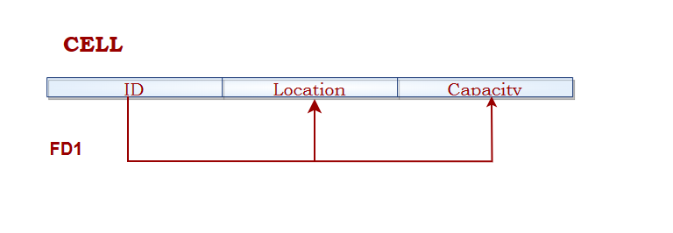

**A.** The **CELL** relation schema satisfies all conditions of the **1NF** because it has neither multivalued attributes nor composite attributes. No nested relations are present as well. All attributes are single and atomic.

**B.** The **CELL** relation schema satisfies all conditions of the **2NF** because every non-prime attribute is fully functionally dependent on the primary key “ID”.

**C.** The **CELL** relation schema satisfies all conditions of the **3NF** because it satisfies the **2NF** and there aren't any non-prime attributes that are transitively dependent on the primary key “ID”.

**D.** The **CELL** relation schema satisfies all conditions of the BCNF because there exists no functional dependency **X→A** where X is not a super key.

## Police Car

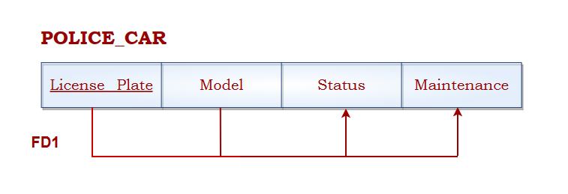

**A.** The **POLICE_CAR** relation schema satisfies all conditions of the **1NF** because it has neither multivalued attributes nor composite attributes. No nested relations are present as well. All attributes are single and atomic.

**B.** The **POLICE_CAR** relation schema satisfies all conditions of the **2NF** because every non-prime attribute is fully functionally dependent on the composite key (LicensePlate, Model).

**C.** The **POLICE_CAR** relation schema satisfies all conditions of the **3NF** because it satisfies the **2NF** and there aren't any non-prime attributes that are transitively dependent on the composite key (LicensePlate, Model).

**D.** The **POLICE_CAR** relation schema satisfies all conditions of the **BCNF** because there exists no functional dependency **X→A** where X is not a super key.

# Schemas Without Any Non-Prime Attributes

## 

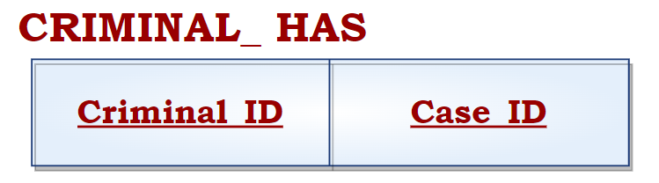

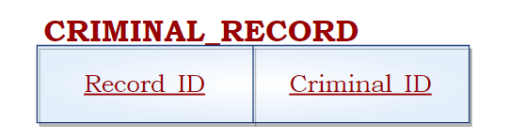

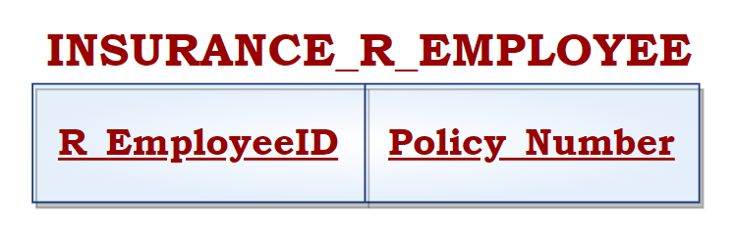

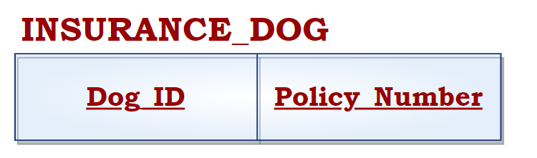

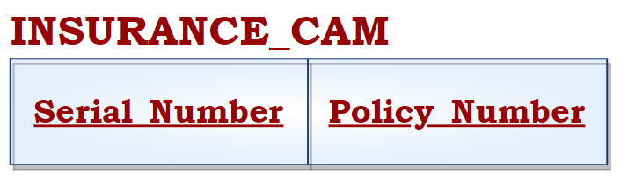

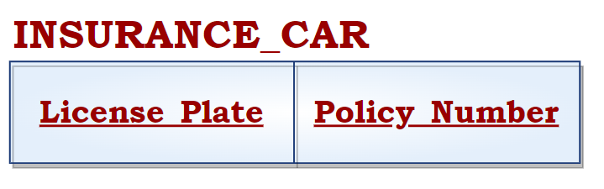

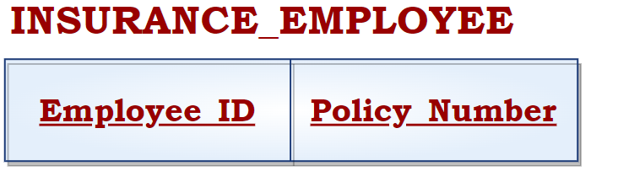

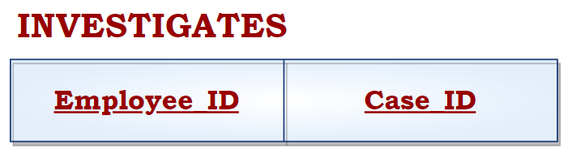

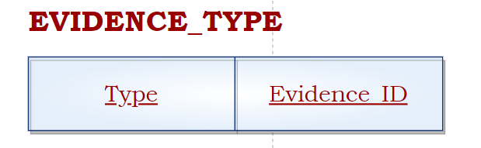

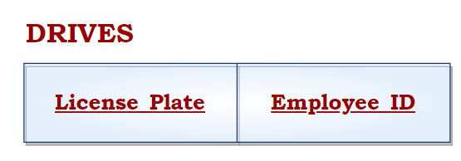

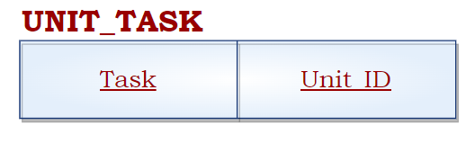

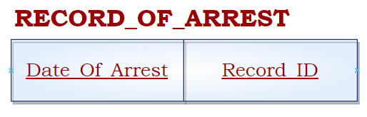

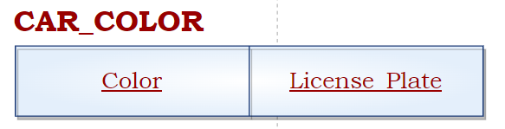

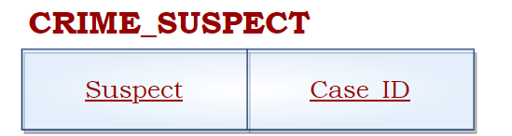

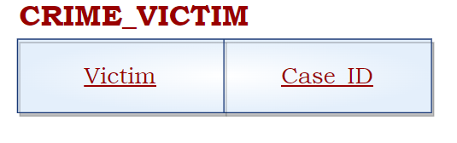

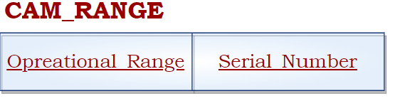

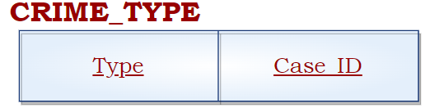

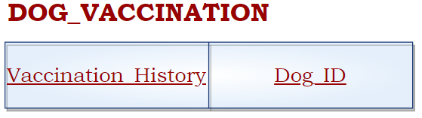

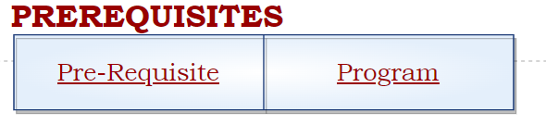

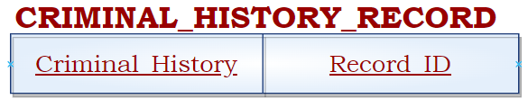

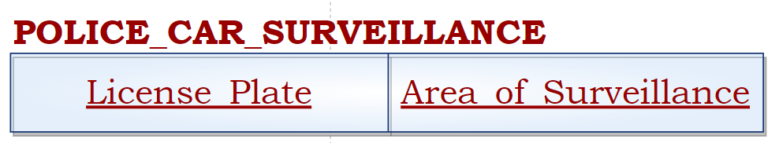

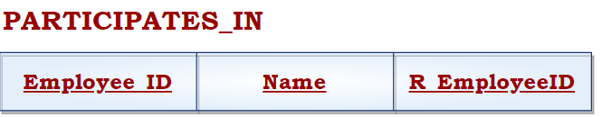

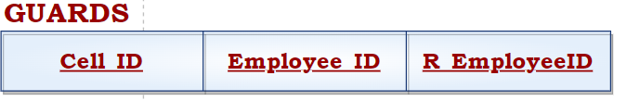

A Thank You Message

***We genuinely had loads of fun (and other emotions we dont speak of) with this project. We gave it 110% and had time permitted, it would’ve been 120%. Hopefully you enjoyed our project as much as we did making it. Thank you from the bottom of our hearts for teaching us with such passion, the passion that fueled us to excel. We look forward to our paths crossing again in the future, and to liking your cute instagram posts ^-^.***

**Team ROKT.N**